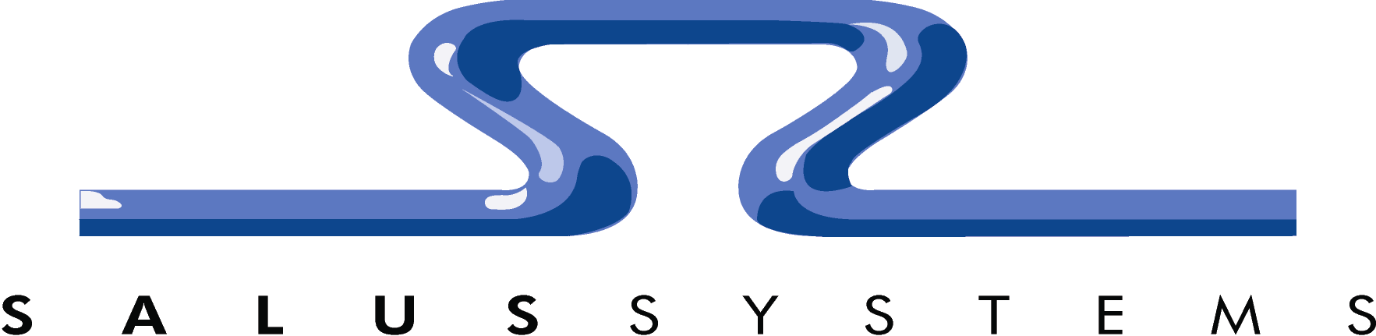

Prepared For:
Ministry of Forests and Range



Corporate Bridge Register (CBR)
Report Design Specifications

April 2, 2009

3318 Oak Street, Suite 23, Victoria BC, V8X 1R1
Telephone: (250) 370-9963 Fax: (250) 370-9950
www.salussystems.com

Table of Contents

Table of Contents 2
1 Introduction 3
1.1 Purpose 3
1.2 Scope 3
1.3 Audience 4
1.4 References and Related Documents 4
2 Reports 5
2.1 Inspection Report 5
2.1.1 Bridge Specific 21
2.1.2 Culvert Specific 22
2.2 Structure Inventory – Summary Report 25
2.3 Structure Inventory – Detailed Report 30
2.4 Structure Detail Report 39
2.4.1 Bridge Specific 51
2.4.2 Culvert Specific 53
2.5 Repairs and Monitors Summary Report 57
2.6 Inspections Conducted Report 64
2.7 Inspections Due – Summary Report 68
2.8 Inspections Due – Detailed Report 74
2.9 Replacement Structures – Summary Report 83
3 Sign-Off 90
4 Document Revisions 91

Introduction

Purpose
The purpose of this document is to provide detailed report design specifications for the Corporate Bridge Register (CBR) application.
This document does not describe the business requirements associated with this application; these requirements are contained in the Corporate Bridge Register Business Requirements Document.

Scope
This document describes the overall technical architecture and detailed design of the CBR application. It addresses the documented business requirements associated with management of inspections and maintenance activities of bridges and major culverts (collectively referred to as major structures) as well as maintenance responsibility, service plan development and access status.
Initial data conversion from the existing Microsoft Access BRIMS application is not covered in this document.

Audience
This document is intended for a range of readers including:
Technical Architects
Security Analysts
Data Administrators
Business Analysts
Systems Analysts
Business Users
Developers

References and Related Documents
Refer to the following documents that provide further information to supplement this document.
Corporate Bridge Register Business Requirements Document
Logical and physical data models in the Ministry’s Oracle Designer repository
MOFR Application Development Site: http://extranet.for.gov.bc.ca/AppDev/
Sun Java Web Start Information: http://java.sun.com/products/javawebstart/
Apache Derby Information: http://db.apache.org/derby/
Apache Axis 1 Information: http://ws.apache.org/axis/

Reports

Inspection Report
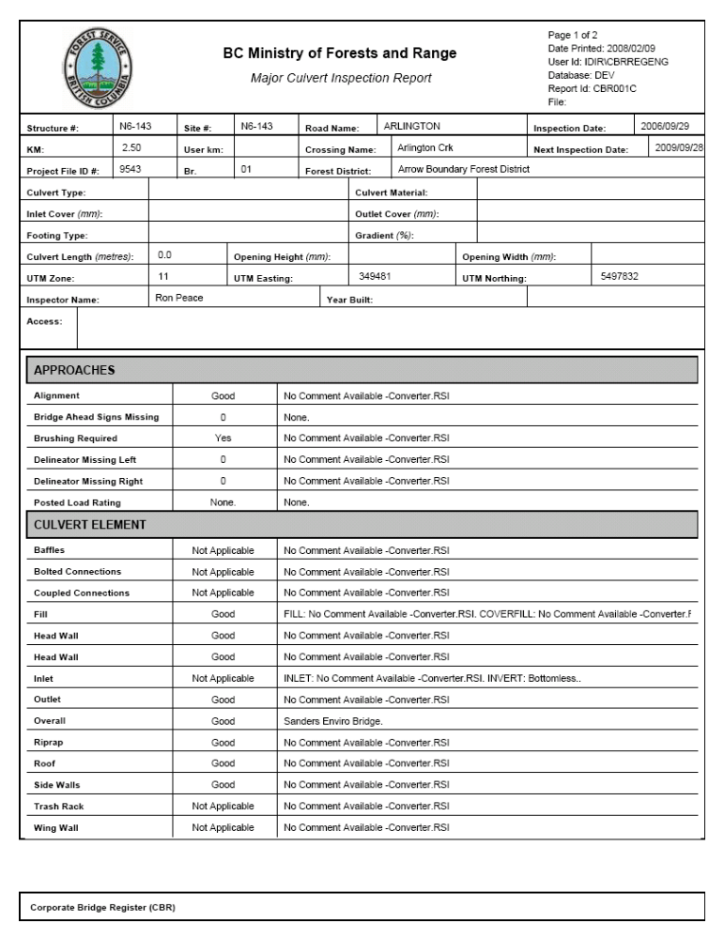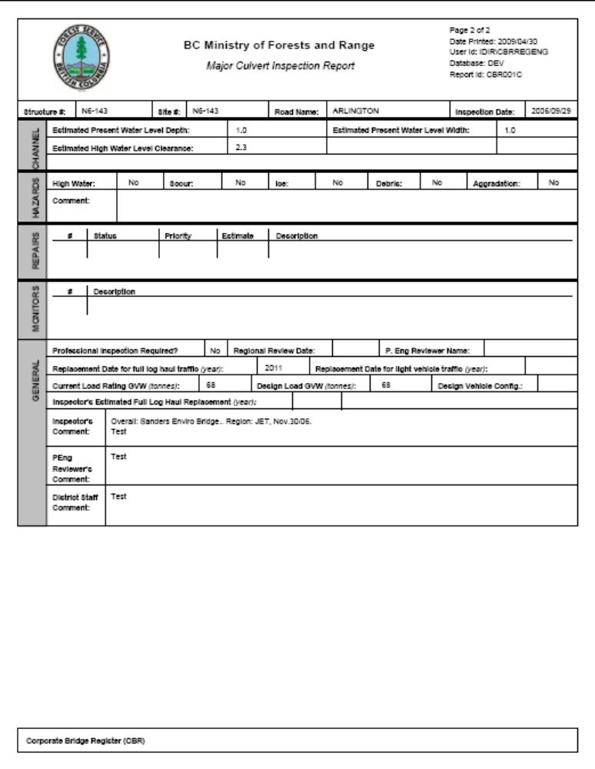
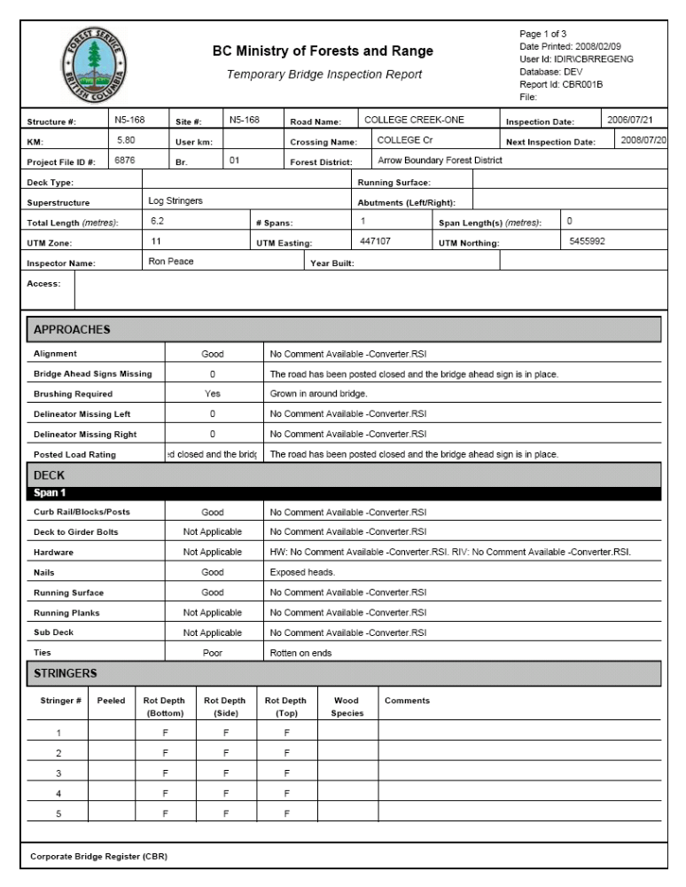
Object: |  | Page
 |  | Type: |  |  | Text
 |  | Description: |  |  | Displays the current page being displayed and the total number of pages in the report.
 |  | Data: |  |  | Output: The current page and the page count (Crystal Reports special fields).
 |  | Special Processing: |  |  | n/a
Object: |  | Date Printed
 |  | Type: |  |  | Text
 |  | Description: |  |  | Displays the date that the report was generated.
 |  | Data: |  |  | Output: The current date at the time of generation (Crystal Reports special field).
 |  | Special Processing: |  |  | n/a
Object: |  | User Id
 |  | Type: |  |  | Text
 |  | Description: |  |  | Displays the user who generated the report.
 |  | Data: |  |  | Output: The user id that requested the generation retrieved from WebADE and passed into the report.
 |  | Special Processing: |  |  | n/a
Object: |  | Database
 |  | Type: |  |  | Text
 |  | Description: |  |  | Displays the database environment that the report data was pulled from.
 |  | Data: |  |  | Output: The database used at the time of generation retrieved from WebADE and passed into the report.
 |  | Special Processing: |  |  | n/a
Object: |  | Report Id
 |  | Type: |  |  | Text
 |  | Description: |  |  | Displays a unique id for the report.
 |  | Data: |  |  | Output: Static report id specific to the report.
 |  | Special Processing: |  |  | Each type of structure appends a different letter onto the end of the report id.
Object: |  | Report Name
 |  | Type: |  |  | Text
 |  | Description: |  |  | Displays the report name.
 |  | Data: |  |  | Output: The name of the report.
 |  | Special Processing: |  |  | Report name is dependant on the type of structure.
Object: |  | Site #
 |  | Type: |  |  | Text
 |  | Description: |  |  | Unique identifier for the physical site where a structure will be installed.
 |  | Data: |  |  | Output: Site # for the record retrieved from CROSSING_SITE.CROSSING_SITE_ID.
 |  | Special Processing: |  |  | n/a
Object: |  | Structure #
 |  | Type: |  |  | Text
 |  | Description: |  |  | Unique identifier assigned to each structure.
 |  | Data: |  |  | Output: Structure # for the record retrieved from CROSSING_STRUCTURE.CROSSING_STRUCTURE_ID.
 |  | Special Processing: |  |  | n/a
Object: |  | Road Name
 |  | Type: |  |  | Text
 |  | Description: |  |  | Forest service road name assigned to the particular site.
 |  | Data: |  |  | Output: Road name for the record retrieved from ROAD_SECTION.ROAD_SECT_NAME.
 |  | Special Processing: |  |  | n/a
Object: |  | Inspection Date
 |  | Type: |  |  | Text
 |  | Description: |  |  | Date that a field inspection is completed.
 |  | Data: |  |  | Output: Inspection date for the record retrieved from STRUCTURE_INSPECTION.INSPECTION_DATE.
 |  | Special Processing: |  |  | n/a
Object: |  | KM
 |  | Type: |  |  | Text
 |  | Description: |  |  | Distance in kilometres from the point of commencement to the road section or system.
 |  | Data: |  |  | Output: Kilometres for the record retrieved from CROSSING_SITE.POINT_OF_COMMENCEMENT_DISTANCE.
 |  | Special Processing: |  |  | n/a
Object: |  | User km
 |  | Type: |  |  | Text
 |  | Description: |  |  | The posted distance (relative to a sign), may vary from Point of Commencement Distance which should be the current measured distance from the start of the road.
 |  | Data: |  |  | Output: User kilometres for the record retrieved from CROSSING_SITE.USER_KM.
 |  | Special Processing: |  |  | n/a
Object: |  | Crossing Name
 |  | Type: |  |  | Text
 |  | Description: |  |  | Common name of crossing for the site.
 |  | Data: |  |  | Output: Crossing name for the record retrieved from CROSSING_SITE.CROSSING_NAME.
 |  | Special Processing: |  |  | n/a
Object: |  | Next Inspection Date
 |  | Type: |  |  | Text
 |  | Description: |  |  | Projected date for the next planned inspection for the structure.
 |  | Data: |  |  | Output: Next inspection date for the record retrieved from CROSSING_STRUCTURE.NEXT_PLANNED_INSPECTION_DATE.
 |  | Special Processing: |  |  | n/a
Object: |  | Project File ID #
 |  | Type: |  |  | Text
 |  | Description: |  |  | Indicates the project file ID # for the associated site.
 |  | Data: |  |  | Output: Project File ID# for the record retrieved from CROSSING_SITE.FOREST_FILE_ID.
 |  | Special Processing: |  |  | n/a
Object: |  | Br.
 |  | Type: |  |  | Text
 |  | Description: |  |  | Indicates the Branch for the associated site.
 |  | Data: |  |  | Output: Branch for the record retrieved from CROSSING_SITE.ROAD_SECTION_ID.
 |  | Special Processing: |  |  | n/a
Object: |  | Forest District
 |  | Type: |  | Text
 |  | Description: |  | The forest district the site currently belongs in.
 |  | Data: |  | Output: Forest district for the record retrieved from CROSSING_SITE.ORG_UNIT_NO.
 |  | Special Processing: |  | n/a
Object: |  | UTM Zone
 |  | Type: |  | Text
 |  | Description: |  | Universal Transverse Mercator (UTM) zone.
 |  | Data: |  | Output: UTM zone for the record retrieved from CROSSING_SITE.UTM_ZONE.
 |  | Special Processing: |  | n/a
Object: |  | UTM Northing
 |  | Type: |  | Text
 |  | Description: |  | The Universal Transverse Mercator (UTM) location reference. The northing reference is metres north of the Equator.
 |  | Data: |  | Output: UTM northing for the record retrieved from CROSSING_SITE.UTM_NORTHING.
 |  | Special Processing: |  | n/a
Object: |  | UTM Easting
 |  | Type: |  | Text
 |  | Description: |  | The Universal Transverse Mercator (UTM) location reference the site. The easting reference is metres east of the Central Meridian of the zone.
 |  | Data: |  | Output: UTM easting for the record retrieved from CROSSING_SITE.UTM_EASTING.
 |  | Special Processing: |  | n/a
Object: |  | Inspector Name
 |  | Type: |  | Text
 |  | Description: |  | The name of the person who performed the inspection on the structure.
 |  | Data: |  | Output: Inspector name for the record retrieved from STRUCTURE_INSPECTION.INSPECTOR_NAME.
 |  | Special Processing: |  | n/a
Object: |  | Year Built
 |  | Type: |  | Text
 |  | Description: |  | The year that the construction of a structure is completed.
 |  | Data: |  | Output: Year built value for the record retrieved from CROSSING_STRUCTURE.YEAR_BUILT.
 |  | Special Processing: |  | n/a
Object: |  | Access
 |  | Type: |  | Text
 |  | Description: |  | This is a comment field which contains directions on how to get to the road system.
 |  | Data: |  | Output: Point of access for the record retrieved from CROSSING_SITE.POINT_OF_ACCESS_DESC.
 |  | Special Processing: |  | n/a
Object: | Subsection
Object: | Type: |  | Text
Object: | Description: |  | Identifies the name of the subsection in which a grouping of questions will be shown (i.e. Deck, Approaches).
Object: | Data: |  | Output: Value retrieved from STRUCTURE_INSPCTN_SUBSCTN_CD.DESCRIPTION.
Object: | Special Processing: |  | Subsections are dynamically generated from the STRCTRE_TYP_INSPCTN_SBSCTN_XRF table depending on the type of structure and the questions answered (i.e., if Approaches is supposed to be shown for a given structure but no questions have been answered in that section it will not be shown).
Object: | Question
Object: | Type: |  | Text
Object: | Description: |  | Identifies question to be asked under a particular subsection
Object: | Data: |  | Output: Value retrieved from STRUCTURE_INSPCTN_QUESTION_CD.DESCRIPTION.
Object: | Special Processing: |  | Questions are dynamically generated from the STRCTRE_INSPCTN_SBSN_XREF table which is dependant on the particular subsection.  The STRCTRE_INSPCTN_QSTN_CRIT_XREF table is also used to determine if a question should be shown under a given subsection based on certain data for the structure.  Questions are only shown if they have been answered.
Object: | Answer
Object: | Type: |  | Text
Object: | Description: |  | The answer that was given for the question.
Object: | Data: |  | Output: The answer for the record is retrieved from STRUCTURE_INSPECTION_ITEM.ANSWER_VALUE.
Object: | Special Processing: |  | n/a
Object: | Comment
Object: | Type: |  | Text
Object: | Description: |  | Comment while holds additional details regarding the answer.
Object: | Data: |  | Output: The comment for the record is retrieved from STRUCTURE_INSPECTION_ITEM.ITEM_COMMENT.
Object: | Special Processing: |  | n/a
Object: | Span <NUMBER>
Object: | Type: |  | Text
Object: | Description: |  | Identifies the span number for which a group of questions relates to.
Object: | Data: |  | Output: The span number is retrieved from FOREST_SERVICE_BRIDGE_SPAN.SPAN_NUMBER.
Object: | Special Processing: |  | Span number is only shown once for each group of questions within a subsection that relate to the span.
Object: | Pier <NUMBER>
Object: | Type: |  | Text
Object: | Description: |  | Identifies the pier number for which a group of the questions relates to.
Object: | Data: |  | Output: The pier number is retrieved from FOREST_SERVICE_BRIDGE_PIER.PIER_NUMBER.
Object: | Special Processing: |  | Pier number is only shown once for each group of questions within a subsection that relate to the pier.
Object: | Stringer List
Object: | Type: |  | Dynamic List
Object: | Description: |  | Displays the questions and answers associated with stringers for the given subsection.
Object: | Data: |  | Output: n/a
Object: | Special Processing: |  | Only displayed for the Stringers and Woodbox Log subsections.  A single stringer item in the list is actually a STRUCTURE_INSPECTION_ITEM per question asked besides the Stringer column (they all just have the same stringer number).
Object: |  | Estimated Present Water Level Depth
 |  | Type: |  | Text
 |  | Description: |  | Estimated average present water level depth for present wetted width.
 |  | Data: |  | Output: Estimated present water level depth value for the record retrieved from STRUCTURE_INSPECTION.CHANNEL_PWL_DEPTH.
 |  | Special Processing: |  | n/a
Object: |  | Estimated Present Water Level Width
 |  | Type: |  | Text
 |  | Description: |  | Estimated average present water level width of the channel at time of inspection measured from edge of water to edge of water.
 |  | Data: |  | Output: Estimated present water level width value for the record retrieved from STRUCTURE_INSPECTION.CHANNEL_PWL_WIDTH.
 |  | Special Processing: |  | n/a
Object: |  | Estimated High Water Level Clearance
 |  | Type: |  | Text
 |  | Description: |  | Estimated minimum high water level clearance to underside of span given visual high water evidence.
 |  | Data: |  | Output: Estimated high water level clearance value for the record retrieved from STRUCTURE_INSPECTION.CHANNEL_HWL_CLEARANCE.
 |  | Special Processing: |  | n/a
Object: |  | High Water
 |  | Type: |  | Text
 |  | Description: |  | Indication that a high water condition exists that could impact the integrity of the bridge.
 |  | Data: |  | Output: High water hazard value for the record retrieved from STRUCTURE_INSPECTION.HIGH_WATER_HAZARD_IND.
 |  | Special Processing: |  | If “Y” is retrieved then “Yes” is displayed, if “N” is retrieved “No” is displayed.
Object: |  | Scour
 |  | Type: |  | Text
 |  | Description: |  | Indication that scour exists that could impact the integrity of the bridge.
 |  | Data: |  | Output: Scour hazard value for the record retrieved from STRUCTURE_INSPECTION.SCOUR_HAZARD_IND.
 |  | Special Processing: |  | If “Y” is retrieved then “Yes” is displayed, if “N” is retrieved “No” is displayed.
Object: |  | Ice
 |  | Type: |  | Text
 |  | Description: |  | Indication that ice exists that could impact the integrity of the bridge.
 |  | Data: |  | Output: Ice hazard value for the record retrieved from STRUCTURE_INSPECTION.ICE_HAZARD_IND.
 |  | Special Processing: |  | If “Y” is retrieved then “Yes” is displayed, if “N” is retrieved “No” is displayed.
Object: |  | Debris
 |  | Type: |  | Text
 |  | Description: |  | Indication that debris exists that could impact the integrity of the bridge.
 |  | Data: |  | Output: Debris hazard value for the record retrieved from STRUCTURE_INSPECTION.DEBRIS_HAZARD_IND.
 |  | Special Processing: |  | If “Y” is retrieved then “Yes” is displayed, if “N” is retrieved “No” is displayed.
Object: |  | Aggradation
 |  | Type: |  | Text
 |  | Description: |  | Indication that aggradation exists that could impact the integrity of the bridge.
 |  | Data: |  | Output: Aggradation hazard value for the record retrieved from STRUCTURE_INSPECTION.AGGRADATION_HAZARD_IND.
 |  | Special Processing: |  | If “Y” is retrieved then “Yes” is displayed, if “N” is retrieved “No” is displayed.
Object: |  | Comment
 |  | Type: |  | Text
 |  | Description: |  | Comment field which further describes any identified hazards.
 |  | Data: |  | Output: Hazard comment for the record retrieved from STRUCTURE_INSPECTION.HAZARD_COMMENT.
 |  | Special Processing: |  | n/a
Object: |  | # (Repairs)
 |  | Type: |  | Text
 |  | Description: |  | Sequential number starting at one of for each repair item identified.
 |  | Data: |  | Output: Repair number for the record retrieved from STRUCTURE_REPAIR.REPAIR_NUMBER.
 |  | Special Processing: |  | n/a
Object: |  | Status
 |  | Type: |  | Text
 |  | Description: |  | The current status of the repair.
 |  | Data: |  | Output: Repair status for the record retrieved from STRUCTURE_REPAIR.REPAIR_STATUS_CODE.
 |  | Special Processing: |  | n/a
Object: |  | Priority
 |  | Type: |  | Text
 |  | Description: |  | The current priority of the repair.
 |  | Data: |  | Output: Repair priority for the record retrieved from STRUCTURE_REPAIR.REPAIR_PRIORITY_CODE.
 |  | Special Processing: |  | n/a
Object: |  | Estimate
 |  | Type: |  | Text
 |  | Description: |  | The inspector or Regional Bridge Engineers estimate as to the cost to complete the repair.
 |  | Data: |  | Output: Repair estimate for the record retrieved from STRUCTURE_REPAIR.ESTIMATE.
 |  | Special Processing: |  | n/a
Object: |  | Description (Repairs)
 |  | Type: |  | Text
 |  | Description: |  | Description of the repair.
 |  | Data: |  | Output: Repair description for the record retrieved from STRUCTURE_REPAIR.DESCRIPTION.
 |  | Special Processing: |  | n/a
Object: |  | # (Monitors)
 |  | Type: |  | Text
 |  | Description: |  | Sequential number starting at one for each monitoring item.
 |  | Data: |  | Output: Monitor record for the record retrieved from STRUCTURE_MONITOR_ITEMS.MONITOR_NUMBER.
 |  | Special Processing: |  | n/a
Object: |  | Description (Monitors)
 |  | Type: |  | Text
 |  | Description: |  | Description of the monitor.
 |  | Data: |  | Output: Monitor description for the record retrieved from STRUCTURE_MONITOR_ITEMS.DESCRIPTION.
 |  | Special Processing: |  | n/a
Object: |  | Professional Inspection Required?
 |  | Type: |  | Text
 |  | Description: |  | Determines if the structure will require a professional engineer review.
 |  | Data: |  | Output: Professional inspection indicator for the record retrieved from STRUCTURE_INSPECTION.PENG_INSPECTION_REQ_IND.
 |  | Special Processing: |  | If “Y” retrieved then “Yes” is displayed, if “N” is retrieved then “No” is displayed
Object: |  | Regional Review Date
 |  | Type: |  | Text
 |  | Description: |  | Date when the professional engineer approves the inspection report.
 |  | Data: |  | Output: Regional review date for the record retrieved from STRUCTURE_INSPECTION.PENG_REVIEWER_DATE.
 |  | Special Processing: |  | n/a
Object: |  | P. Eng Reviewer Name
 |  | Type: |  | Text
 |  | Description: |  | The name of the professional engineer who reviewed the inspection report.
 |  | Data: |  | Output: Professional reviewer name for the record retrieved from STRUCTURE_INSPECTION_REVIEWER.FIRST_NAME and STRUCTURE_INSPECTION_REVIEWER_LAST_NAME.
 |  | Special Processing: |  | n/a
Object: |  | Replacement Date for full log haul traffic
 |  | Type: |  | Text
 |  | Description: |  | Replacement date to accommodate full industrial use.
 |  | Data: |  | Output: Full log replacement date for the record retrieved from CROSSING_STRUCTURE.FULL_LOG_HAUL_TRFFC_RPLCMNT_DT.
 |  | Special Processing: |  | n/a
Object: |  | Replacement Date for light vehicle traffic
 |  | Type: |  | Text
 |  | Description: |  | Replacement date to accommodate no less than 5 ton structures.
 |  | Data: |  | Output: Light vehicle replacement date for the record retrieved from STRUCTURE_INSPECTION. LIGHT_VEHICLE_TRFFC_RPLCMNT_DT.
 |  | Special Processing: |  | n/a
Object: |  | Current Load Rating GVW
 |  | Type: |  | Text
 |  | Description: |  | The present capacity of the structure.
 |  | Data: |  | Output: Load rating for the record retrieved from CROSSING_STRUCTURE.LOAD_RATING.
 |  | Special Processing: |  | n/a
Object: |  | Design Load GVW
 |  | Type: |  | Text
 |  | Description: |  | The capacity of the bridge superstructure when it was first constructed.
 |  | Data: |  | Output: Design load rating for the record retrieved from CROSSING_STRUCTURE.DESIGN_LOAD_RATING.
 |  | Special Processing: |  | n/a
Object: |  | Design Vehicle Config.
 |  | Type: |  | Text
 |  | Description: |  | The configuration of the vehicle used to determine design load rating.
 |  | Data: |  | Output: Design vehicle configuration value for the record retrieved from CROSSING_STRUCTURE.DESIGN_VEHICLE_LOAD_CODE.
 |  | Special Processing: |  | n/a
Object: |  | Inspector’s Estimated Full Log Haul Replacement
 |  | Type: |  | Text
 |  | Description: |  | The estimated year that the inspector feels a full log haul replacement is required.
 |  | Data: |  | Output: Estimated year for the record retrieved from STRUCTURE_INSPECTION.INSP_FULL_LOG_HAUL_RPLCMNT_DT.
 |  | Special Processing: |  | n/a
Object: |  | Inspector’s Comment
 |  | Type: |  | Text
 |  | Description: |  | Comments by the inspector.
 |  | Data: |  | Output: Inspection comment for the record retrieved from STRUCTURE_INSPECTION.INSPECTION_COMMENT.
 |  | Special Processing: |  | n/a
Object: |  | PEng Reviewer’s Comment
 |  | Type: |  | Text
 |  | Description: |  | Comments by the reviewing professional engineer.
 |  | Data: |  | Output: Inspection comment for the record retrieved from STRUCTURE_INSPECTION.PROF_ENG_REVIEWER_COMMENT.
 |  | Special Processing: |  | n/a
Object: |  | District Staff Comment
 |  | Type: |  | Text
 |  | Description: |  | Comments by the district staff.
 |  | Data: |  | Output: Inspection comment for the record retrieved from STRUCTURE_INSPECTION.DISTRICT_STAFF_COMMENT.
 |  | Special Processing: |  | n/a

Bridge Specific
Object: | Deck Type
Object: | Type: | Text
Object: | Description: | Identifies what the deck can be composed of.
Object: | Data: | Output: Deck type value for the record retrieved from FOREST_SERVICE_BRIDGE.DECK_TYPE_CODE.
Object: | Special Processing: | n/a
Object: | Running Surface
Object: | Type: | Text
Object: | Description: | Identifies the material that the surface of the bridge is composed of.
Object: | Data: | Output: Running surface value for the record retrieved from FOREST_SERVICE_BRIDGE.RUNNING_SURFACE_CODE.
Object: | Special Processing: | n/a
Object: | Superstructure
Object: | Type: | Text
Object: | Description: | Identifies the type of the superstructure.
Object: | Data: | Output: Superstructure type value for the record retrieved from FOREST_SERVICE_BRIDGE.SUPERSTRUCTURE_TYPE_CODE.
Object: | Special Processing: | n/a
Object: | Abutments (Left/Right)
Object: | Type: | Text
Object: | Description: | Identifies the type of the left and right abutment.
Object: | Data: | Output: Left abutment value for the record retrieved from FOREST_SERVICE_BRIDGE.LEFT_ABUTMENT_CODE. Right abutment value for the record retrieved from FOREST_SERVICE_BRIDGE.RIGHT_ABUTMENT_CODE.
Object: | Special Processing: | If the left and right abutment are the same the type is only shown once otherwise the left and right type are displayed.
Object: | Total Length
Object: | Type: | Text
Object: | Description: | Length from one bridge end to the other end measured at bridge deck at center line.
Object: | Data: | Output: Total length value for the record retrieved from FOREST_SERVICE_BRIDGE.TOTAL_BRIDGE_LENGTH.
Object: | Special Processing: | n/a
Object: | # Spans
Object: | Type: | Text
Object: | Description: | Identifies number of spans associated with the structure.
Object: | Data: | Output: A count of associated records in FOREST_SERVICE_BRIDGE_SPAN.
Object: | Special Processing: | n/a
Object: | Span Lengths
Object: | Type: | Text
Object: | Description: | Identifies the lengths of all of the associated spans.
Object: | Data: | Output: Retrieves the FOREST_SERVICE_BRIDGE_SPAN.SPAN_LENGTH value for each of the associated span records.
Object: | Special Processing: | n/a

Culvert Specific
Object: | Culvert Type
Object: | Type: | Text
Object: | Description: | Identifies the type of the culvert.
Object: | Data: | Output: The culvert type value for the record retrieved from FOREST_SERVICE_CULVERT. ENGINEERED_CULVERT_TYPE_CODE.
Object: | Special Processing: | n/a
Object: | Culvert Material
Object: | Type: | Text
Object: | Description: | Identifies the material of the culvert.
Object: | Data: | Output: Culvert material value for the record retrieved from FOREST_SERVICE_CULVERT. ENGINEERED_CULVERT_MATERIAL_CD.
Object: | Special Processing: | n/a
Object: | Inlet Cover
Object: | Type: | Text
Object: | Description: | The depth of soil fill over upstream end of the culvert at the edge of the road surface.
Object: | Data: | Output: Inlet cover value for the record retrieved from FOREST_SERVICE_CULVERT.INLET_COVER_DEPTH.
Object: | Special Processing: | n/a
Object: | Outlet Cover
Object: | Type: | Text
Object: | Description: | The depth of soil fill over the downstream end of the culvert at the edge of the road surface.
Object: | Data: | Output: Outlet cover value for the record retrieved from FOREST_SERVICE_CULVERT.OUTLET_COVER_DPETH.
Object: | Special Processing: | n/a
Object: | Footing Type
Object: | Type: | Text
Object: | Description: | Identifies the type of materials that the foundation of an open bottom culvert is composed of.
Object: | Data: | Output: Footing type value for the record retrieved from FOREST_SERVICE_CULVERT. OPN_BOTTOM_CLVRT_SUBSTRCTRE_CD.
Object: | Special Processing: | n/a
Object: | Gradient
Object: | Type: | Text
Object: | Description: | The slope of culvert expressed as a percentage.
Object: | Data: | Output: Gradient value for the record retrieved from FOREST_SERVICE_CULVERT.SLOPE.
Object: | Special Processing: | n/a
Object: | Culvert Length
Object: | Type: | Text
Object: | Description: | Length of a culvert along the direction of the watercourse.
Object: | Data: | Output: Culvert length value for the record retrieved from FOREST_SERVICE_CULVERT.CULVERT_LENGTH.
Object: | Special Processing: | n/a
Object: | Opening Height
Object: | Type: | Text
Object: | Description: | The height from the base of the culvert to the inside top.
Object: | Data: | Output: Opening height value for the record retrieved from FOREST_SERVICE_CULVERT.OPENING_HEIGHT.
Object: | Special Processing: | n/a
Object: | Opening Width
Object: | Type: | Text
Object: | Description: | Inside wall to wall distance of a culvert.
Object: | Data: | Output: Opening width value for the record retrieved from FOREST_SERVICE_CULVERT.OPENING_WIDTH.
Object: | Special Processing: | n/a

Structure Inventory – Summary Report
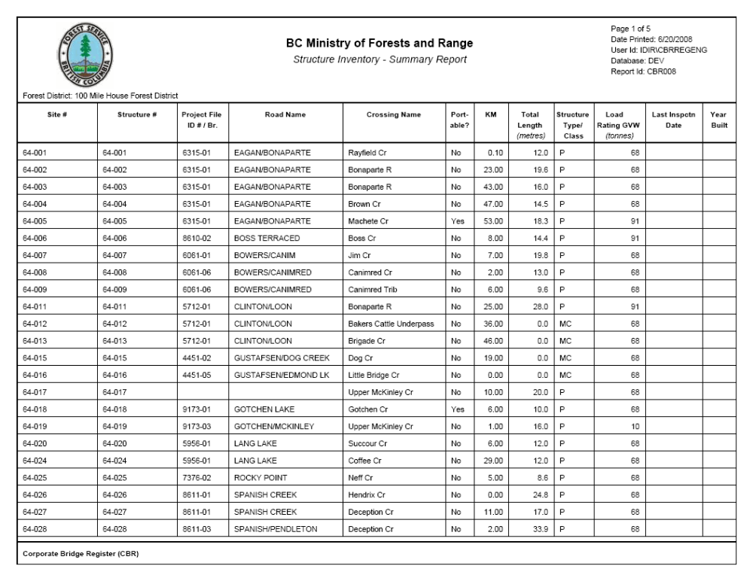
Object: | Page
Object: | Type: | Text
Object: | Description: | Displays the current page being displayed and the total number of pages in the report.
Object: | Data: | Output: The current page and the page count (Crystal Reports special fields).
Object: | Special Processing: | n/a
Object: | Date Printed
Object: | Type: | Text
Object: | Description: | Displays the date that the report was generated.
Object: | Data: | Output: The current date at the time of generation (Crystal Reports special field).
Object: | Special Processing: | n/a
Object: | User Id
Object: | Type: | Text
Object: | Description: | Displays the user who generated the report.
Object: | Data: | Output: The user id that requested the generation retrieved from WebADE and passed into the report.
Object: | Special Processing: | n/a
Object: | Database
Object: | Type: | Text
Object: | Description: | Displays the database environment that the report data was pulled from.
Object: | Data: | Output: The database used at the time of generation retrieved from WebADE and passed into the report.
Object: | Special Processing: | n/a
Object: | Report Id
Object: | Type: | Text
Object: | Description: | Displays a unique id for the report.
Object: | Data: | Output: Static report id specific to the report.
Object: | Special Processing: | n/a
Object: | Selected Criteria (located under the Forest Service Icon)
Object: | Type: | Text
Object: | Description: | Displays the criteria specified when generating the report.
Object: | Data: | Output: Criteria selected for generation of the report.
Object: | Special Processing: | n/a
Object: | Site #
Object: | Type: | Text
Object: | Description: | Unique identifier for the physical site where a structure will be installed.
Object: | Data: | Output: Site # for the record retrieved from CROSSING_SITE.CROSSING_SITE_ID.
Object: | Special Processing: | n/a
Object: | Structure #
Object: | Type: | Text
Object: | Description: | Unique identifier assigned to each structure.
Object: | Data: | Output: Structure # for the record retrieved from CROSSING_STRUCTURE.CROSSING_STRUCTURE_ID.
Object: | Special Processing: | n/a
Object: | Project File ID# / Br.
Object: | Type: | Text
Object: | Description: | Project File ID# and Branch assigned to the particular site.
Object: | Data: | Output: Project Fie ID# for the record retrieved from CROSSING_SITE.FOREST_FILE_ID and Branch for the record retrieved from CROSSING_SITE.ROAD_SECTION_ID.
Object: | Special Processing: | n/a
Object: | Road Name
Object: | Type: | Text
Object: | Description: | Forest service road name assigned to the particular site.
Object: | Data: | Output: Road name for the record retrieved from ROAD_SECTION.ROAD_SECT_NAME.
Object: | Special Processing: | n/a
Object: | Crossing Name
Object: | Type: | Text
Object: | Description: | Common name of crossing for the site.
Object: | Data: | Output: Crossing name for the record retrieved from CROSSING_SITE.CROSSING_NAME.
Object: | Special Processing: | n/a
Object: | Portable?
Object: | Type: | Text
Object: | Description: | Identifies if the structure is portable or not.
Object: | Data: | Output: Portable indicator for the record retrieved from CROSSING_STRUCTURE.PORTABLE_STRUCTURE_IND.
Object: | Special Processing: | n/a
Object: | KM
Object: | Type: | Text
Object: | Description: | Distance in kilometres from the point of commencement to the road section or system.
Object: | Data: | Output: Kilometres for the record retrieved from CROSSING_SITE.POINT_OF_COMMENCEMENT_DISTANCE.
Object: | Special Processing: | n/a
Object: | Total Length
Object: | Type: | Text
Object: | Description: | For bridges: Length from one bridge end to the other end measured at bridge deck at center line.  For culverts: Length of a culvert along direction of the watercourse.
Object: | Data: | Output: Total length for bridge structures for the record retrieved from FOREST_SERVICE_BRIDGE.TOTAL_LENGTH. Total length for culvert structures for the record retrieved from FOREST_SERVICE_CULVERT.CULVERT_LENGTH.
Object: | Special Processing: | Different field is displayed depending on the structure type.
Object: | Structure Type/Class
Object: | Type: | Text
Object: | Description: | Identifies the (major) structure type.
Object: | Data: | Output: A converted form of the value retrieved from CROSSING_STRUCTURE.STRUCTURE_TYPE_CLASS_CODE.
Object: | Special Processing: | Data retrieved is converted as follows:  PB B, TB T, CUL MC, WLC W
Object: | Load Rating
Object: | Type: | Text
Object: | Description: | The present capacity of the structure.
Object: | Data: | Output: Load rating for the record is retrieved from CROSSING_STRUCTURE.LOAD_RATING.
Object: | Special Processing: | n/a
Object: | Last Inspection Date
Object: | Type: | Text
Object: | Description: | The date of the last inspection for the structure that was ‘Accepted’.
Object: | Data: | Output: Last inspection date for the record is retrieved from STRUCTURE_INSPECTION.INSPECTION_DATE.
Object: | Special Processing: | n/a
Object: | Year Built
Object: | Type: | Text
Object: | Description: | The year that the construction of a structure is completed.
Object: | Data: | Output: Year built data for the record is retrieved from CROSSING_STRUCTURE.YEAR_BUILT.
Object: | Special Processing: | n/a

Structure Inventory – Detailed Report
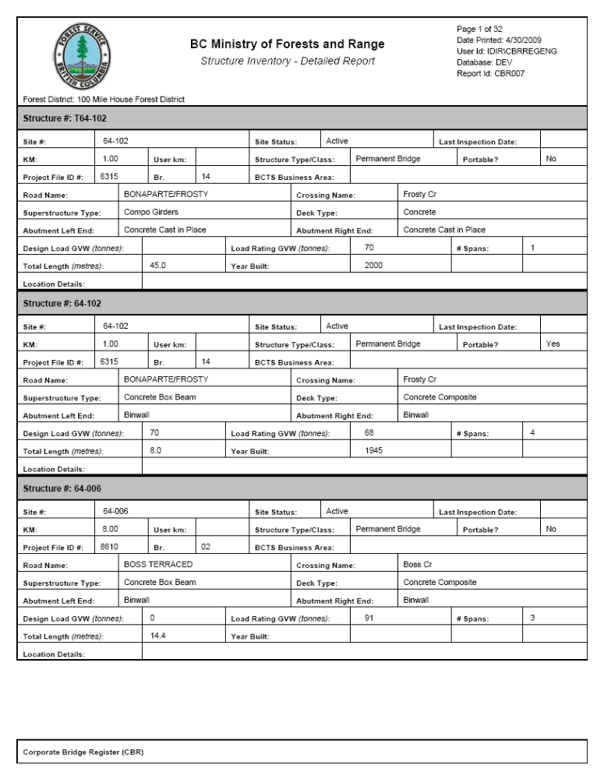
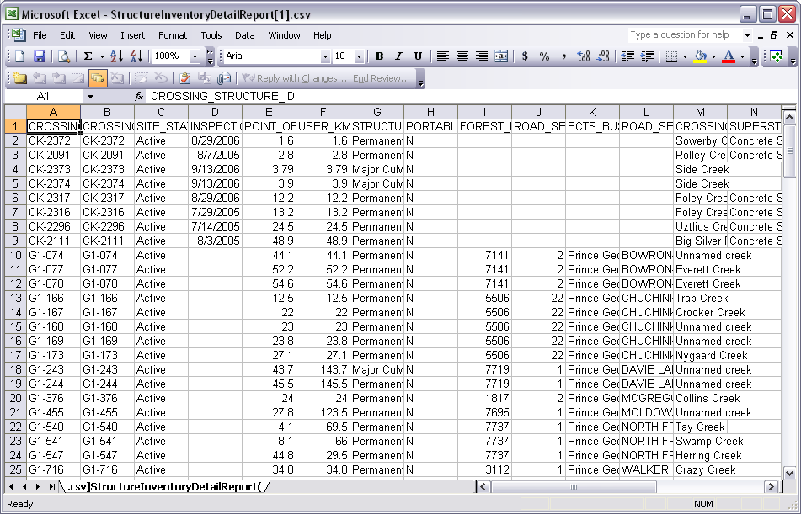

Object: | Page
Object: | Type: | Text
Object: | Description: | Displays the current page being displayed and the total number of pages in the report.
Object: | Data: | Output: The current page and the page count (Crystal Reports special fields).
Object: | Special Processing: | n/a
Object: | Date Printed
Object: | Type: | Text
Object: | Description: | Displays the date that the report was generated.
Object: | Data: | Output: The current date at the time of generation (Crystal Reports special field).
Object: | Special Processing: | n/a
Object: | User Id
Object: | Type: | Text
Object: | Description: | Displays the user who generated the report.
Object: | Data: | Output: The user id that requested the generation retrieved from WebADE and passed into the report.
Object: | Special Processing: | n/a
Object: | Database
Object: | Type: | Text
Object: | Description: | Displays the database environment that the report data was pulled from.
Object: | Data: | Output: The database used at the time of generation retrieved from WebADE and passed into the report.
Object: | Special Processing: | n/a
Object: | Report Id
Object: | Type: | Text
Object: | Description: | Displays a unique id for the report.
Object: | Data: | Output: Static report id specific to the report.
Object: | Special Processing: | n/a
Object: | Selected Criteria (located under the Forest Service Icon)
Object: | Type: | Text
Object: | Description: | Displays the criteria specified when generating the report.
Object: | Data: | Output: Criteria selected for generation of the report.
Object: | Special Processing: | n/a
Object: | Structure #
Object: | Type: | Text
Object: | Description: | Unique identifier assigned to each structure.
Object: | Data: | Output: Structure # for the record retrieved from CROSSING_STRUCTURE.CROSSING_STRUCTURE_ID.
Object: | Special Processing: | n/a
Object: | Site #
Object: | Type: | Text
Object: | Description: | Unique identifier for the physical site where a structure will be installed.
Object: | Data: | Output: Site # for the record retrieved from CROSSING_SITE.CROSSING_SITE_ID.
Object: | Special Processing: | n/a
Object: | Site Status
Object: | Type: | Text
Object: | Description: | Identifies the current status of the site.
Object: | Data: | Output: Site status for the record retrieved from CROSSING_SITE.CROSSING_SITE_STATUS_CODE.
Object: | Special Processing: | n/a
Object: | Last Inspection Date
Object: | Type: | Text
Object: | Description: | The date of the last inspection for the structure that was ‘Accepted’.
Object: | Data: | Output: Last inspection date for the record is retrieved from STRUCTURE_INSPECTION.INSPECTION_DATE.
Object: | Special Processing: | n/a
Object: | KM
Object: | Type: | Text
Object: | Description: | Distance in kilometres from the point of commencement to the road section or system.
Object: | Data: | Output: Kilometres for the record retrieved from CROSSING_SITE.POINT_OF_COMMENCEMENT_DISTANCE.
Object: | Special Processing: | n/a
Object: | User km
Object: | Type: | Text
Object: | Description: | The posted distance (relative to a sign), may vary from Point of Commencement Distance which should be the current measured distance from the start of the road.
Object: | Data: | Output: User kilometres for the record retrieved from CROSSING_SITE.USER_KM.
Object: | Special Processing: | n/a
Object: | Structure Type/Class
Object: | Type: | Text
Object: | Description: | Identifies the (major) structure type.
Object: | Data: | Output: Structure type for the record retrieved from CROSSING_STRUCTURE.STRUCTURE_TYPE_CLASS_CODE.
Object: | Special Processing: | n/a
Object: | Portable?
Object: | Type: | Text
Object: | Description: | Indicates if the structure was designed to be easily moved from site to site.
Object: | Data: | Output: Portable indicator for the record retrieved from CROSSING_STRUCTURE.PORTABLE_STRUCTURE_IND.
Object: | Special Processing: | If data returned is “Y” then “Yes” is displayed, if data returned is “N” then “No” is displayed.
Object: | Project File ID #
Object: | Type: | Text
Object: | Description: | Indicates the project file ID # for the associated site.
Object: | Data: | Output: Project File ID# for the record retrieved from CROSSING_SITE.FOREST_FILE_ID.
Object: | Special Processing: | n/a
Object: | Br.
Object: | Type: | Text
Object: | Description: | Indicates the Branch for the associated site.
Object: | Data: | Output: Branch for the record retrieved from CROSSING_SITE.ROAD_SECTION_ID.
Object: | Special Processing: | n/a
Object: | BCTS Business Area
Object: | Type: | Text
Object: | Description: | Indicates the BCTS business area for the associated site.
Object: | Data: | Output: BCTS business area for the record retrieved from CROSSING_SITE.BUSINESS_AREA_ORG_UNIT_NO.
Object: | Special Processing: | n/a
Object: | Road Name
Object: | Type: | Text
Object: | Description: | Indicates the forest service road name for the associated site.
Object: | Data: | Output: Forest service road name for the record retrieved from ROAD_SECTION.ROAD_SECT_NAME.
Object: | Special Processing: | n/a
Object: | Crossing Name
Object: | Type: | Text
Object: | Description: | Common name of crossing.
Object: | Data: | Output: Crossing name for the record retrieved from CROSSING_SITE.CROSSING_NAME.
Object: | Special Processing: | n/a
Object: | Superstructure Type
Object: | Type: | Text
Object: | Description: | Identifies the type of the superstructure.
Object: | Data: | Output: Superstructure type for the record retrieved from FOREST_SERVICE_BRIDGE.SUPERSTRUCTURE_TYPE_CODE.
Object: | Special Processing: | n/a
Object: | Deck Type
Object: | Type: | Text
Object: | Description: | Identifies what the deck can be composed of.
Object: | Data: | Output: Deck type for the record retrieved from FOREST_SERVICE_BRIDGE.DECK_TYPE_CODE.
Object: | Special Processing: | n/a
Object: | Abutment Left End
Object: | Type: | Text
Object: | Description: | Identifies the type of the left abutment.
Object: | Data: | Output: Left abutment type for the record retrieved from FOREST_SERVICE_BRIDGE.LEFT_ABUTMENT_CODE.
Object: | Special Processing: | n/a
Object: | Abutment Right End
Object: | Type: | Text
Object: | Description: | Identifies the type of the right abutment.
Object: | Data: | Output: Right abutment type for the record retrieved from FOREST_SERVICE_BRIDGE.RIGHT_ABUTMENT_CODE.
Object: | Special Processing: | n/a
Object: | Design Load GVW
Object: | Type: | Text
Object: | Description: | The capacity of the bridge superstructure when it was first constructed.
Object: | Data: | Output: Design load rating for the record retrieved from CROSSING_STRUCTURE.DESIGN_LOAD_RATING.
Object: | Special Processing: | n/a
Object: | Load Rating GVW
Object: | Type: | Text
Object: | Description: | The present capacity of the structure.
Object: | Data: | Output: Load rating for the record retrieved from CROSSING_STRUCTURE.LOAD_RATING.
Object: | Special Processing: | n/a
Object: | # Spans
Object: | Type: | Text
Object: | Description: | Identifies the number of spans for the given structure.
Object: | Data: | Output: Number of spans for the record retrieved from a count of associated records in FOREST_SERVICE_BRIDGE_SPAN.
Object: | Special Processing: | n/a
Object: | Total Length
Object: | Type: | Text
Object: | Description: | For bridges: Length from one bridge end to the other end measured at bridge deck at center line.  For culverts: Length of a culvert along direction of the watercourse.
Object: | Data: | Output: Total length for bridge structures for the record retrieved from FOREST_SERVICE_BRIDGE.TOTAL_LENGTH. Total length for culvert structures for the record retrieved from FOREST_SERVICE_CULVERT.CULVERT_LENGTH.
Object: | Special Processing: | Different field is displayed depending on the structure type.
Object: | Year Built
Object: | Type: | Text
Object: | Description: | The year that the construction of a structure is completed.
Object: | Data: | Output: Year built for the record retrieved from CROSSING_STRUCTURE.YEAR_BUILT.
Object: | Special Processing: | n/a
Object: | Location Details
Object: | Type: | Text
Object: | Description: | Comments related to the location of the portable superstructure.
Object: | Data: | Output: Location details for the record retrieved from FOREST_SERVICE_BRIDGE.PORTABLE_SPRSTRCTRE_LOCN_DTL.
Object: | Special Processing: | n/a

Structure Detail Report
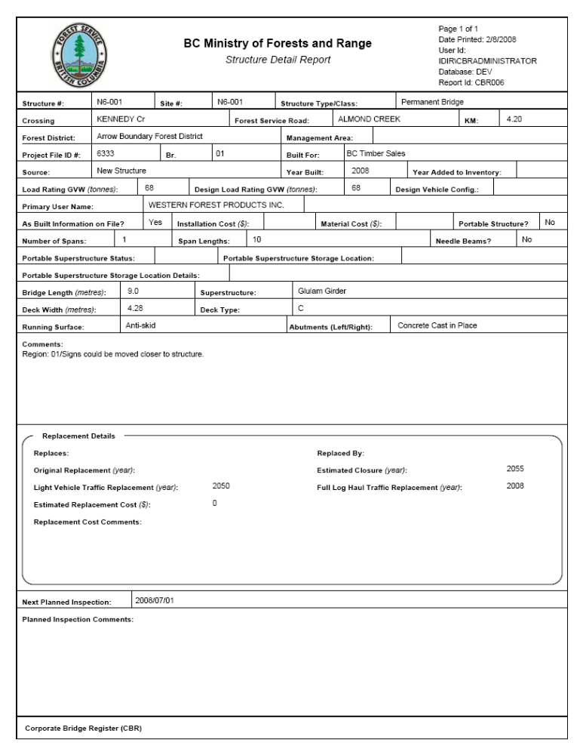
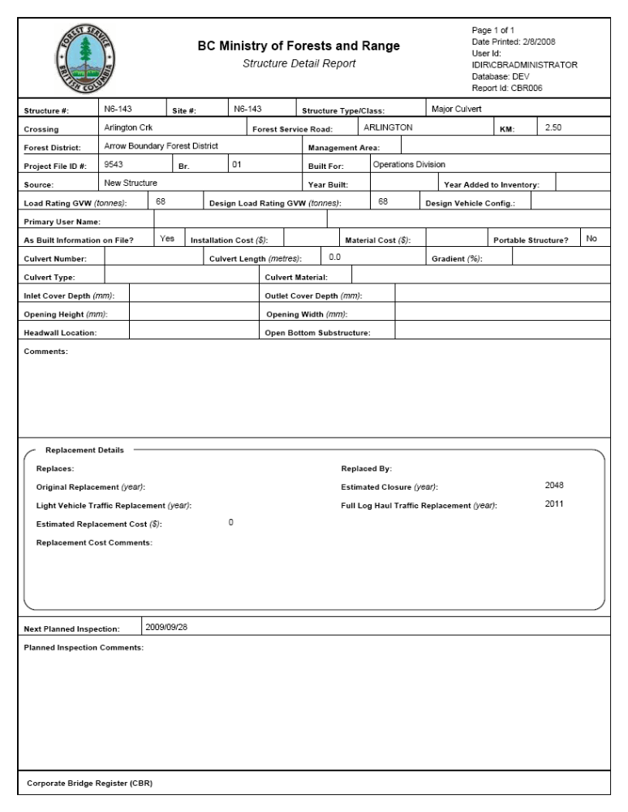
Object: | Page
Object: | Type: |  | Text
Object: | Description: |  | Displays the current page being displayed and the total number of pages in the report.
Object: | Data: |  | Output: The current page and the page count (Crystal Reports special fields).
Object: | Special Processing: |  | n/a
Object: | Date Printed
Object: | Type: |  | Text
Object: | Description: |  | Displays the date that the report was generated.
Object: | Data: |  | Output: The current date at the time of generation (Crystal Reports special field).
Object: | Special Processing: |  | n/a
Object: | User Id
Object: | Type: |  | Text
Object: | Description: |  | Displays the user who generated the report.
Object: | Data: |  | Output: The user id that requested the generation retrieved from WebADE and passed into the report.
Object: | Special Processing: |  | n/a
Object: | Database
Object: | Type: |  | Text
Object: | Description: |  | Displays the database environment that the report data was pulled from.
Object: | Data: |  | Output: The database used at the time of generation retrieved from WebADE and passed into the report.
Object: | Special Processing: |  | n/a
Object: | Report Id
Object: | Type: |  | Text
Object: | Description: |  | Displays a unique id for the report.
Object: | Data: |  | Output: Static report id specific to the report.
Object: | Special Processing: |  | n/a
Object: | Structure #
Object: | Type: |  | Text
Object: | Description: |  | Unique identifier assigned to each structure.
Object: | Data: |  | Output: Structure # for the record retrieved from CROSSING_STRUCTURE.CROSSING_STRUCTURE_ID.
Object: | Special Processing: |  | n/a
Object: | Site #
Object: | Type: |  | Text
Object: | Description: |  | Unique identifier for the physical site where a structure will be installed.
Object: | Data: |  | Output: Site # for the record retrieved from CROSSING_SITE.CROSSING_SITE_ID.
Object: | Special Processing: |  | n/a
Object: | Structure Type/Class
Object: | Type: |  | Text
Object: | Description: |  | Identifies the (major) structure type.
Object: | Data: |  | Output: Structure type for the record retrieved from CROSSING_STRUCTURE.STRUCTURE_TYPE_CLASS_CODE.
Object: | Special Processing: |  | n/a
Object: | Crossing Name
Object: | Type: |  | Text
Object: | Description: |  | Common name of crossing.
Object: | Data: |  | Output: Crossing name for the record retrieved from CROSSING_SITE.CROSSING_NAME.
Object: | Special Processing: |  | n/a
Object: | Forest Service Road Name
Object: | Type: |  | Text
Object: | Description: |  | Indicates the forest service road name for the associated site.
Object: | Data: |  | Output: Forest service road name for the record retrieved from ROAD_SECTION.ROAD_SECT_NAME.
Object: | Special Processing: |  | n/a
Object: | KM
Object: | Type: |  | Text
Object: | Description: |  | Distance in kilometres from the point of commencement to the road section or system.
Object: | Data: |  | Output: Kilometres for the record retrieved from CROSSING_SITE.POINT_OF_COMMENCEMENT_DISTANCE.
Object: | Special Processing: |  | n/a
Object: | Forest District
Object: | Type: |  | Text
Object: | Description: |  | The forest district the site currently belongs in.
Object: | Data: |  | Output: Forest district for the record retrieved from CROSSING_SITE.ORG_UNIT_NO.
Object: | Special Processing: |  | n/a
Object: | Management Area
Object: | Type: |  | Text
Object: | Description: |  | The management area the site currently belongs in.
Object: | Data: |  | Output: Management area for the record retrieved from CROSSING_SITE.MANAGEMENT_ORG_UNIT_NO.
Object: | Special Processing: |  | n/a
Object: | Project File ID #
Object: | Type: |  | Text
Object: | Description: |  | Indicates the project file ID # for the associated site.
Object: | Data: |  | Output: Project File ID# for the record retrieved from CROSSING_SITE.FOREST_FILE_ID.
Object: | Special Processing: |  | n/a
Object: | Br.
Object: | Type: |  | Text
Object: | Description: |  | Indicates the Branch for the associated site.
Object: | Data: |  | Output: Branch for the record retrieved from CROSSING_SITE.ROAD_SECTION_ID.
Object: | Special Processing: |  | n/a
Object: | Built For
Object: | Type: |  | Text
Object: | Description: |  | Identifies which organization the structure was originally built for.
Object: | Data: |  | Output: Built for value for the record retrieved from CROSSING_STRUCTURE.BUILT_BY_CODE.
Object: | Special Processing: |  | n/a
Object: | Source
Object: | Type: |  | Text
Object: | Description: |  | A source identifies the means by which the selected structure came to be owned by the Ministry.
Object: | Data: |  | Output: Source value for the record retrieved from CROSSING_STRUCTURE.STRUCTURE_SOURCE_CODE.
Object: | Special Processing: |  | n/a
Object: | Year Built
Object: | Type: |  | Text
Object: | Description: |  | The year that the construction of a structure is completed.
Object: | Data: |  | Output: Year built value for the record retrieved from CROSSING_STRUCTURE.YEAR_BUILT.
Object: | Special Processing: |  | n/a
Object: | Year Added to Inventory
Object: | Type: |  | Text
Object: | Description: |  | The year that the construction was inherited or found and was recorded as part of the Ministry’s inventory.
Object: | Data: |  | Output: Year added to inventory value for the record retrieved from CROSSING_STRUCTURE.INVENTORY_ADDED_YEAR.
Object: | Special Processing: |  | n/a
Object: | Load Rating GVW
Object: | Type: |  | Text
Object: | Description: |  | The present capacity of the structure.
Object: | Data: |  | Output: Load rating for the record retrieved from CROSSING_STRUCTURE.LOAD_RATING.
Object: | Special Processing: |  | n/a
Object: | Design Load GVW
Object: | Type: |  | Text
Object: | Description: |  | The capacity of the bridge superstructure when it was first constructed.
Object: | Data: |  | Output: Design load rating for the record retrieved from CROSSING_STRUCTURE.DESIGN_LOAD_RATING.
Object: | Special Processing: |  | n/a
Object: | Design Vehicle Config.
Object: | Type: |  | Text
Object: | Description: |  | The configuration of the vehicle used to determine design load rating.
Object: | Data: |  | Output: Design vehicle configuration value for the record retrieved from CROSSING_STRUCTURE.DESIGN_VEHICLE_LOAD_CODE.
Object: | Special Processing: |  | n/a
Object: | Primary User Name
Object: | Type: |  | Text
Object: | Description: |  | The primary user name for the structure.
Object: | Data: |  | Output: Primary user name value for the record retrieved from FOREST_CLIENT.CLIENT_NAME.
Object: | Special Processing: |  | n/a
Object: | As Built Information on File?
Object: | Type: |  | Text
Object: | Description: |  | This flag identifies if the as-built information is part of the structure record.
Object: | Data: |  | Output: As-built flag value for the record retrieved from CROSSING_STRUCTURE.AS_BUILT_INFO_PRESENT_IND.
Object: | Special Processing: |  | n/a
Object: | Installation Cost
Object: | Type: |  | Text
Object: | Description: |  | The cost of installation used in the construction of a structure.
Object: | Data: |  | Output: Installation cost for the record retrieved from CROSSING_STRUCTURE.INSTALLATION_COST.
Object: | Special Processing: |  | n/a
Object: | Material Cost
Object: | Type: |  | Text
Object: | Description: |  | The cost components used in the construction of a structure.
Object: | Data: |  | Output: Material cost for the record retrieved from CROSSING_STRUCTURE.MATERIAL_COST.
Object: | Special Processing: |  | n/a
Object: | Portable?
Object: | Type: |  | Text
Object: | Description: |  | Indicates if the structure was designed to be easily moved from site to site.
Object: | Data: |  | Output: Portable indicator for the record retrieved from CROSSING_STRUCTURE.PORTABLE_STRUCTURE_IND.
Object: | Special Processing: |  | If data returned is “Y” then “Yes” is displayed, if data returned is “N” then “No” is displayed.
Object: | Comments
Object: | Type: |  | Text
Object: | Description: |  | Comment field which will contain details of issues related to the structure.
Object: | Data: |  | Output: Comments for the record retrieved from CROSSING_STRUCTURE.STRUCTURE_COMMENT.
Object: | Special Processing: |  | n/a
Object: | Replaces
Object: | Type: | Text
Object: | Description: | Identifies which structures that the current structure has replaced.
Object: | Data: | Output: The structures identified in STRUCTURE_REPLACEMENT_XREF.REPLACED_STRUCTURE_NUMBER where the STRUCTURE_REPLACEMENT_XREF.REPLACES_STRUCTURE_NUMBER matches the current CROSSING_STRUCTURE.CROSSING_STRUCTURE_ID.
Object: | Special Processing: | n/a
Object: | Replaced By
Object: | Type: | Text
Object: | Description: | Identifies which structures that the current structure has been replaced by.
Object: | Data: | Output: The structures identified in STRUCTURE_REPLACEMENT_XREF.REPLACES_STRUCTURE_NUMBER where the STRUCTURE_REPLACEMENT_XREF.REPLACED_STRUCTURE_NUMBER matches the current CROSSING_STRUCTURE.CROSSING_STRUCTURE_ID.
Object: | Special Processing: | n/a
Object: | Original Replacement
Object: | Type: |  | Text
Object: | Description: |  | The replacement date of the structure as determined at the time of acquisition or construction.
Object: | Data: |  | Output: Original replacement value for the record retrieved from CROSSING_STRUCTURE.ORIGINAL_REPLACEMENT_DATE.
Object: | Special Processing: |  | n/a
Object: | Estimated Closure
Object: | Type: |  | Text
Object: | Description: |  | Estimated date when structure will be required to be closed and is usually a few years beyond the light traffic replacement date.
Object: | Data: |  | Output: Estimated closure value for the record retrieved from CROSSING_STRUCTURE.ESTIMATED_CLOSURE_DATE.
Object: | Special Processing: |  | n/a
Object: | Light Vehicle Traffic Replacement
Object: | Type: |  |  | Text
Object: | Description: |  |  | Replacement date to accommodate no less than 5 ton structures. The original date is determined once at time of construction.
Object: | Data: |  |  | Output: Light traffic replacement value for the record retrieved from CROSSING_STRUCTURE.LIGHT_VEHICLE_TRFFC_RPLCMNT_DT.
Object: | Special Processing: |  |  | n/a
Object: | Full Log Haul Traffic Replacement
Object: | Type: |  |  | Text
Object: | Description: |  |  | Replacement date to accommodate full industrial use. The original date is determined once at time of construction.
Object: | Data: |  |  | Output: Full log replacement value for the record retrieved from CROSSING_STRUCTURE.FULL_LOG_HAUL_TRFFC_RPLCMNT_DT.
Object: | Special Processing: |  |  | n/a
Object: | Estimated Replacement Cost
Object: | Type: |  |  | Text
Object: | Description: |  |  | Estimated cost to replace structure. Determined at time of original construction as well as from inspection to inspection.
Object: | Data: |  |  | Output: Estimated replacement cost value for the record retrieved from CROSSING_STRUCTURE.ESTIMATED_REPLACEMENT_COST.
Object: | Special Processing: |  |  | n/a
Object: | Replacement Cost Comments
Object: | Type: |  |  | Text
Object: | Description: |  |  | A common field which contains the rational for the basis of the value input for estimated replacement cost.
Object: | Data: |  |  | Output: Replacement cost comment value for the record retrieved from CROSSING_STRUCTURE. ESTIMATED_REPLACEMENT_COST_CMT.
Object: | Special Processing: |  |  | n/a
Object: | Next Planned Inspection
Object: | Type: |  |  | Text
Object: | Description: |  |  | Projected date for the next planned inspection for the structure.
Object: | Data: |  |  | Output: Next planned inspection value for the record retrieved from CROSSING_STRUCTURE.NEXT_PLANNED_INSPECTION_DATE.
Object: | Special Processing: |  |  | n/a
Object: | Planned Inspection Comments
Object: | Type: |  |  | Text
Object: | Description: |  |  | Comments relating to the next planned inspection date.
Object: | Data: |  |  | Output: Planned inspection comment value for the record retrieved from CROSSING_STRUCTURE.NEXT_PLANNED_INSPECTION_CMT.
Object: | Special Processing: |  |  | n/a

Bridge Specific
Object: | Number of Spans
Object: | Type: |  | Text
Object: | Description: |  | Identifies the number of spans for the structure.
Object: | Data: |  | Output: Number of spans value for the record retrieved from the record count in FOREST_SERVICE_BRIDGE_SPAN.
Object: | Special Processing: |  | n/a
Object: | Span Lengths
Object: | Type: |  | Text
Object: | Description: |  | Identifies the lengths of all the spans for the structure.
Object: | Data: |  | Output: A length for each span is retrieved from FOREST_SERVICE_BRIDGE_SPAN.SPAN_LENGTH.
Object: | Special Processing: |  | n/a
Object: | Needle Beams?
Object: | Type: | Text
Object: | Description: | Indicates if the structure is a needle beam structure.
Object: | Data: | Output: Needle beam indicator for the record retrieved from FOREST_SERVICE_BRIDGE.NEEDLE_BEAM_IND.
Object: | Special Processing: | If data returned is “Y” then “Yes” is displayed, if data returned is “N” then “No” is displayed.
Object: | Portable Superstructure Status
Object: | Type: | Text
Object: | Description: | Indicate whether a structure is installed at a road site or is in storage if is portable.
Object: | Data: | Output: Portable superstructure status value for the record retrieved from FOREST_SERVICE_BRIDGE.PRTBLE_SUPERSTRUCTURE_STS_CD.
Object: | Special Processing: | n/a
Object: | Portable Superstructure Storage Location
Object: | Type: | Text
Object: | Description: | Identifies the org unit where the portable structure is located.
Object: | Data: | Output: Portable superstructure storage location value for the record retrieved from FOREST_SERVICE_BRIDGE.ORG_UNIT_NO.
Object: | Special Processing: | n/a
Object: | Portable Superstructure Storage Location Details
Object: | Type: | Text
Object: | Description: | Comments related to the location of the portable superstructure.
Object: | Data: | Output: Portable superstructure storage locations details for the record retrieved from FOREST_SERVICE_BRIDGE.PORTABLE_SPRSTRCTRE_LOCN_DTL.
Object: | Special Processing: | n/a
Object: | Bridge Length
Object: | Type: | Text
Object: | Description: | Length from one bridge end to the other end measured at bridge deck at center line.
Object: | Data: | Output: Bridge length value for the record retrieved from FOREST_SERVICE_BRIDGE.TOTAL_BRIDGE_LENGTH.
Object: | Special Processing: | n/a
Object: | Superstructure
Object: | Type: | Text
Object: | Description: | Identifies the type of the superstructure.
Object: | Data: | Output: Superstructure type value for the record retrieved from FOREST_SERVICE_BRIDGE.SUPERSTRUCTURE_TYPE_CODE or FOREST_SERVICE_BRIDGE.SUPERSTRUCTURE_COMMENT.
Object: | Special Processing: | If comment is present it is shown, otherwise the pre-defined code description.
Object: | Deck Width
Object: | Type: | Text
Object: | Description: | Minimum available running surface (i.e., the bridge deck that is driven on between curbs).
Object: | Data: | Output: Deck width value for the record retrieved from FOREST_SERVICE_BRIDGE.DECK_WIDTH.
Object: | Special Processing: | n/a
Object: | Deck Type
Object: | Type: | Text
Object: | Description: | Identifies what the deck can be composed of.
Object: | Data: | Output: Deck type value for the record retrieved from FOREST_SERVICE_BRIDGE.DECK_TYPE_CODE or FOREST_SERVICE_BRIDGE.DECK_TYPE_COMMENT.
Object: | Special Processing: | If comment is present it is shown, otherwise the pre-defined code description.
Object: | Running Surface
Object: | Type: | Text
Object: | Description: | Identifies the material that the surface of the bridge is composed of.
Object: | Data: | Output: Running surface type value for the record retrieved from FOREST_SERVICE_BRIDGE.RUNNING_SURFACE_CODE.
Object: | Special Processing: | n/a
Object: | Abutments (Left/Right)
Object: | Type: | Text
Object: | Description: | Identifies the type of the left and right abutment.
Object: | Data: | Output: Left abutment value for the record retrieved from FOREST_SERVICE_BRIDGE.LEFT_ABUTMENT_CODE. Right abutment value for the record retrieved from FOREST_SERVICE_BRIDGE.RIGHT_ABUTMENT_CODE. If comment present it is retrieved from FOREST_SERVICE_BRIDGE.ABUTMENT_COMENT.
Object: | Special Processing: | If comment is present it is shown, otherwise the pre-defined code description(s).  If the left and right abutment are the same the type is only shown once otherwise the left and right type are displayed.

Culvert Specific
Object: | Culvert Number
Object: | Type: | Text
Object: | Description: | Identifies where the culvert is starting from the left bank.
Object: | Data: | Output: Culvert number for the record retrieved from FOREST_SERVICE_CULVERT.CULVERT_NUMBER.
Object: | Special Processing: | n/a
Object: | Culvert Length
Object: | Type: | Text
Object: | Description: | Length of a culvert along direction of the watercourse.
Object: | Data: | Output: Culvert length for the record retrieved from FOREST_SERVICE_CULVERT.CULVERT_LENGTH.
Object: | Special Processing: | n/a
Object: | Gradient
Object: | Type: | Text
Object: | Description: | The slop of culvert expressed as a percentage (rise over run ratio).
Object: | Data: | Output: Gradient value for the record retrieved from FOREST_SERVICE_CULVERT.SLOPE.
Object: | Special Processing: | n/a
Object: | Culvert Type
Object: | Type: | Text
Object: | Description: | Identifies the type of the culvert.
Object: | Data: | Output: Culvert type value for the record retrieved from FOREST_SERVICE_CULVERT.ENGINEERED_CULVERT_TYPE_CODE.
Object: | Special Processing: | n/a
Object: | Culvert Material
Object: | Type: | Text
Object: | Description: | Identifies the material of the culvert.
Object: | Data: | Output: Culvert material value for the record retrieved from FOREST_SERVICE_CULVERT. ENGINEERED_CULVERT_MATERIAL_CODE or FOREST_SERVICE_CULVERT.CULVERT_MATERIAL_COMMENT.
Object: | Special Processing: | If comment is present it is shown, otherwise the pre-defined code description.
Object: | Inlet Cover Depth
Object: | Type: | Text
Object: | Description: | The depth of soil fill over upstream end of the culvert at the edge of the road surface.
Object: | Data: | Output: Inlet cover depth value for the record retrieved from FOREST_SERVICE_CULVERT.INLET_COVER_DEPTH.
Object: | Special Processing: | n/a
Object: | Outlet Cover Depth
Object: | Type: | Text
Object: | Description: | The depth of soil fill over the downstream end of the culvert at the edge of the road surface.
Object: | Data: | Output: Outlet covert depth value for the record retrieved from FOREST_SERVICE_CULVERT.OUTLET_COVER_DEPTH.
Object: | Special Processing: | n/a
Object: | Opening Height
Object: | Type: | Text
Object: | Description: | The height from the base of the culvert to the inside top.
Object: | Data: | Output: Opening height value for the record retrieved from FOREST_SERVICE_CULVERT.OPENING_HEIGHT.
Object: | Special Processing: | n/a
Object: | Opening Width
Object: | Type: | Text
Object: | Description: | Inside wall to wall distance of a culvert.
Object: | Data: | Output: Opening width value for the record retrieved from FOREST_SERVICE_CULVERT.OPENING_WIDTH.
Object: | Special Processing: | n/a
Object: | Headwall Location
Object: | Type: | Text
Object: | Description: | Identifies the location of the headwall.
Object: | Data: | Output: Headwall location value for the record retrieved from FOREST_SERVICE_CULVERT.HEADWALL_LOCATION_CODE.
Object: | Special Processing: | n/a
Object: | Open Bottom Substructure
Object: | Type: | Text
Object: | Description: | Identifies the type of materials that the foundation of an open bottom culvert is composed of.
Object: | Data: | Output: Open bottom substructure value for the record retrieved from FOREST_SERVICE_CULVERT. OPN_BOTTOM_CLVRT_SUBSTRCTRE_CD.
Object: | Special Processing: | n/a

Repairs and Monitors Summary Report
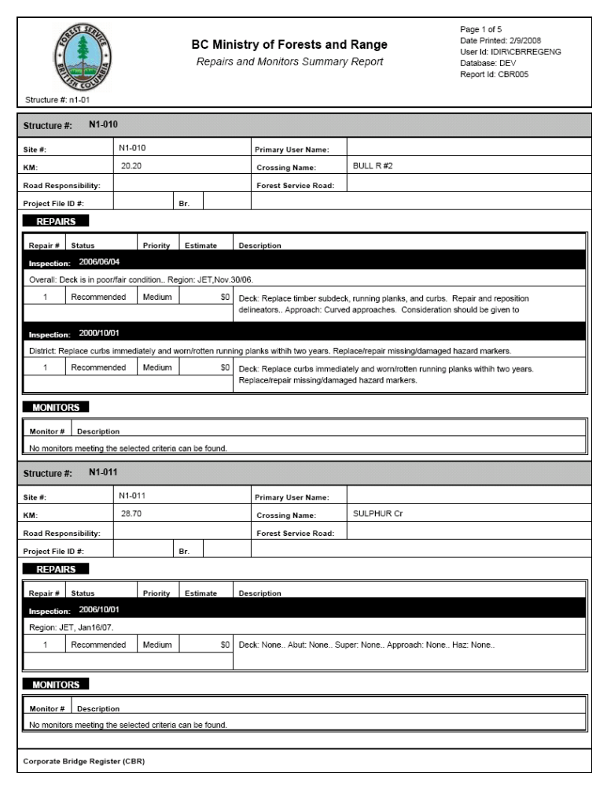
Object: | Page
Object: | Type: |  | Text
Object: | Description: |  | Displays the current page being displayed and the total number of pages in the report.
Object: | Data: |  | Output: The current page and the page count (Crystal Reports special fields).
Object: | Special Processing: |  | n/a
Object: | Date Printed
Object: | Type: |  | Text
Object: | Description: |  | Displays the date that the report was generated.
Object: | Data: |  | Output: The current date at the time of generation (Crystal Reports special field).
Object: | Special Processing: |  | n/a
Object: | User Id
Object: | Type: |  | Text
Object: | Description: |  | Displays the user who generated the report.
Object: | Data: |  | Output: The user id that requested the generation retrieved from WebADE and passed into the report.
Object: | Special Processing: |  | n/a
Object: | Database
Object: | Type: |  | Text
Object: | Description: |  | Displays the database environment that the report data was pulled from.
Object: | Data: |  | Output: The database used at the time of generation retrieved from WebADE and passed into the report.
Object: | Special Processing: |  | n/a
Object: | Report Id
Object: | Type: |  | Text
Object: | Description: |  | Displays a unique id for the report.
Object: | Data: |  | Output: Static report id specific to the report.
Object: | Special Processing: |  | n/a
Object: | Selected Criteria (located under the Forest Service Icon)
Object: | Type: |  | Text
Object: | Description: |  | Displays the criteria specified when generating the report.
Object: | Data: |  | Output: Criteria selected for generation of the report.
Object: | Special Processing: |  | n/a
Object: | Structure #
Object: | Type: |  | Text
Object: | Description: |  | Unique identifier assigned to each structure.
Object: | Data: |  | Output: Structure # for the record retrieved from CROSSING_STRUCTURE.CROSSING_STRUCTURE_ID.
Object: | Special Processing: |  | n/a
Object: | Site #
Object: | Type: |  | Text
Object: | Description: |  | Unique identifier for the physical site where a structure will be installed.
Object: | Data: |  | Output: Site # for the record retrieved from CROSSING_SITE.CROSSING_SITE_ID.
Object: | Special Processing: |  | n/a
Object: | Primary User Name
Object: | Type: | Text
Object: | Description: | The primary user name for the structure.
Object: | Data: | Output: Primary user name value for the record retrieved from FOREST_CLIENT.CLIENT_NAME.
Object: | Special Processing: | n/a
Object: | KM
Object: | Type: | Text
Object: | Description: | Distance in kilometres from the point of commencement to the road section or system.
Object: | Data: | Output: Kilometres for the record retrieved from CROSSING_SITE.POINT_OF_COMMENCEMENT_DISTANCE.
Object: | Special Processing: | n/a
Object: | Crossing Name
Object: | Type: | Text
Object: | Description: | Common name of crossing.
Object: | Data: | Output: Crossing name for the record retrieved from CROSSING_SITE.CROSSING_NAME.
Object: | Special Processing: | n/a
Object: | Road Responsibility
Object: | Type: | Text
Object: | Description: | Identifies who is responsible for the maintenance of the road.
Object: | Data: | Output: Road responsibility for the record retrieved from ROAD_SEGMENT.ROAD_RESPONSIBILITY_TYPE_CODE.
Object: | Special Processing: | n/a
Object: | Forest Service Road Name
Object: | Type: | Text
Object: | Description: | Indicates the forest service road name for the associated site.
Object: | Data: | Output: Forest service road name for the record retrieved from ROAD_SECTION.ROAD_SECT_NAME.
Object: | Special Processing: | n/a
Object: | Project File ID #
Object: | Type: | Text
Object: | Description: | Indicates the project file ID # for the associated site.
Object: | Data: | Output: Project File ID# for the record retrieved from CROSSING_SITE.FOREST_FILE_ID.
Object: | Special Processing: | n/a
Object: | Br.
Object: | Type: | Text
Object: | Description: | Indicates the Branch for the associated site.
Object: | Data: | Output: Branch for the record retrieved from CROSSING_SITE.ROAD_SECTION_ID.
Object: | Special Processing: | n/a
Object: | Repair #
Object: | Type: | Text
Object: | Description: | Sequential number starting at one for each repair item identified on a structure or inspection report.
Object: | Data: | Output: Repair number for the record retrieved from STRUCTURE_REPAIR.REPAIR_NUMBER.
Object: | Special Processing: | n/a
Object: | Status
Object: | Type: | Text
Object: | Description: | The current status of the repair.
Object: | Data: | Output: Repair status value for the record retrieved from STRUCTURE_REPAIR.REPAIR_STATUS_CODE.
Object: | Special Processing: | n/a
Object: | Priority
Object: | Type: | Text
Object: | Description: | The current priority of the repair.
Object: | Data: | Output: Repair priority value for the record retrieved from STRUCTURE_REPAIR.REPAIR_PRIORITY_CODE.
Object: | Special Processing: | n/a
Object: | Estimate
Object: | Type: | Text
Object: | Description: | The inspector or Regional Bridge Engineers estimate as to the cost to complete the repair.
Object: | Data: | Output: Estimate value for the record retrieved from STRUCTURE_REPAIR.ESTIMATE.
Object: | Special Processing: | n/a
Object: | Description
Object: | Type: | Text
Object: | Description: | Description of the repair.
Object: | Data: | Output: Description value for the record retrieved from STRUCTURE_REPAIR.DESCRIPTION.
Object: | Special Processing: | n/a
Object: | Inspection
Object: | Type: | Text
Object: | Description: | Header to identify the inspection the repairs or monitors grouped under it belongs to.
Object: | Data: | Output: Inspection date for the record retrieved from STRUCTURE_INSPECTION.INSPECTION_DATE.
Object: | Special Processing: | n/a
Object: | Inspection Comment (located under any Inspection heading)
Object: | Type: | Text
Object: | Description: | Comments regarding the inspection by inspector and reviewing professional engineer
Object: | Data: | Output: Inspection comment for the record retrieved from STRUCTURE_INSPECTION.INSPECTION_COMMENT.
Object: | Special Processing: | n/a
Object: | Monitor #
Object: | Type: | Text
Object: | Description: | Sequential number starting at one for each monitoring item found for an inspection or for the structure directly.
Object: | Data: | Output: Monitor number for the record retrieved from STRUCTURE_MONITOR_ITEMS.MONITOR_NUMBER.
Object: | Special Processing: | n/a
Object: | Monitor Description
Object: | Type: | Text
Object: | Description: | Description for monitoring item.
Object: | Data: | Output: Description value for the record retrieved from STRUCTURE_MONITOR_ITEMS.DESCRIPTION.
Object: | Special Processing: | n/a

Inspections Conducted Report
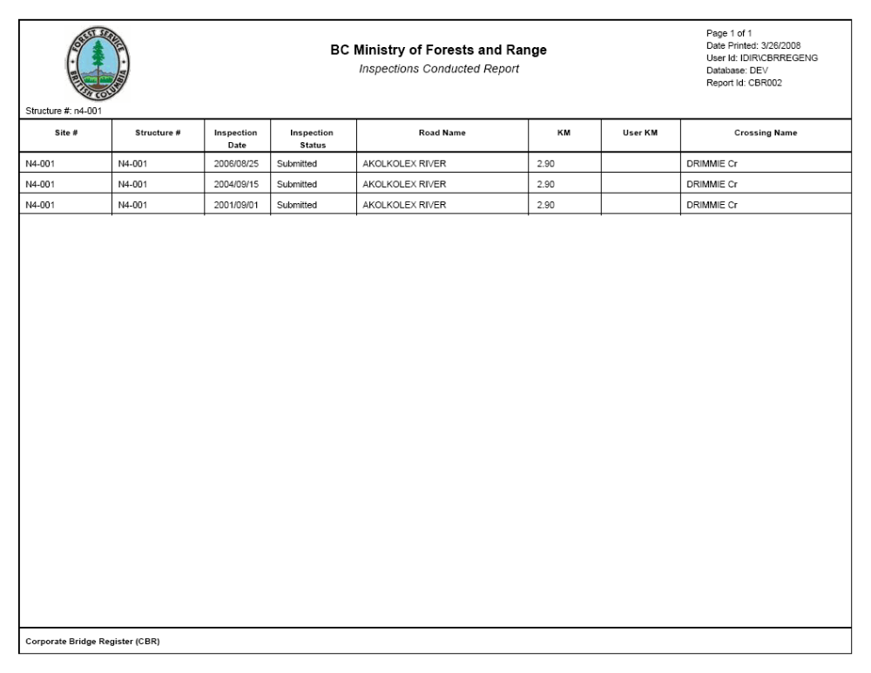
Object: | Page
Object: | Type: |  | Text
Object: | Description: |  | Displays the current page being displayed and the total number of pages in the report.
Object: | Data: |  | Output: The current page and the page count (Crystal Reports special fields).
Object: | Special Processing: |  | n/a
Object: | Date Printed
Object: | Type: |  | Text
Object: | Description: |  | Displays the date that the report was generated.
Object: | Data: |  | Output: The current date at the time of generation (Crystal Reports special field).
Object: | Special Processing: |  | n/a
Object: | User Id
Object: | Type: |  | Text
Object: | Description: |  | Displays the user who generated the report.
Object: | Data: |  | Output: The user id that requested the generation retrieved from WebADE and passed into the report.
Object: | Special Processing: |  | n/a
Object: | Database
Object: | Type: |  | Text
Object: | Description: |  | Displays the database environment that the report data was pulled from.
Object: | Data: |  | Output: The database used at the time of generation retrieved from WebADE and passed into the report.
Object: | Special Processing: |  | n/a
Object: | Report Id
Object: | Type: |  | Text
Object: | Description: |  | Displays a unique id for the report.
Object: | Data: |  | Output: Static report id specific to the report.
Object: | Special Processing: |  | n/a
Object: | Selected Criteria (located under the Forest Service Icon)
Object: | Type: |  | Text
Object: | Description: |  | Displays the criteria specified when generating the report.
Object: | Data: |  | Output: Criteria selected for generation of the report.
Object: | Special Processing: |  | n/a
Object: | Structure #
Object: | Type: |  | Text
Object: | Description: |  | Unique identifier assigned to each structure.
Object: | Data: |  | Output: Structure # for the record retrieved from CROSSING_STRUCTURE.CROSSING_STRUCTURE_ID.
Object: | Special Processing: |  | n/a
Object: | Site #
Object: | Type: |  | Text
Object: | Description: |  | Unique identifier for the physical site where a structure will be installed.
Object: | Data: |  | Output: Site # for the record retrieved from CROSSING_SITE.CROSSING_SITE_ID.
Object: | Special Processing: |  | n/a
Object: | Inspection Date
Object: | Type: |  | Text
Object: | Description: |  | Date that a field inspection is completed.
Object: | Data: |  | Output: Inspection date for the record retrieved from STRUCTURE_INSPECTION.INSPECTION_DATE.
Object: | Special Processing: |  | n/a
Object: | Inspection Status
Object: | Type: |  | Text
Object: | Description: |  | The current status of the inspection.
Object: | Data: |  | Output: Inspection status for the record retrieved from STRUCTURE_INSPECTION.INSPECTION_REPORT_STATUS_CODE.
Object: | Special Processing: |  | n/a
Object: | Forest Service Road Name
Object: | Type: | Text
Object: | Description: | Indicates the forest service road name for the associated site.
Object: | Data: | Output: Forest service road name for the record retrieved from ROAD_SECTION.ROAD_SECT_NAME.
Object: | Special Processing: | n/a
Object: | Crossing Name
Object: | Type: | Text
Object: | Description: | Common name of crossing.
Object: | Data: | Output: Crossing name for the record retrieved from CROSSING_SITE.CROSSING_NAME.
Object: | Special Processing: | n/a
Object: | KM
Object: | Type: | Text
Object: | Description: | Distance in kilometres from the point of commencement to the road section or system.
Object: | Data: | Output: Kilometres for the record retrieved from CROSSING_SITE.POINT_OF_COMMENCEMENT_DISTANCE.
Object: | Special Processing: | n/a
Object: | User KM
Object: | Type: | Text
Object: | Description: | The posted distance (relative to a sign), may vary from the Point of Commencement Distance which should be the current measured distance from the start of the road.
Object: | Data: | Output: User kilometres for the record retrieved from CROSSING_SITE.USER_KM.
Object: | Special Processing: | n/a

Inspections Due – Summary Report
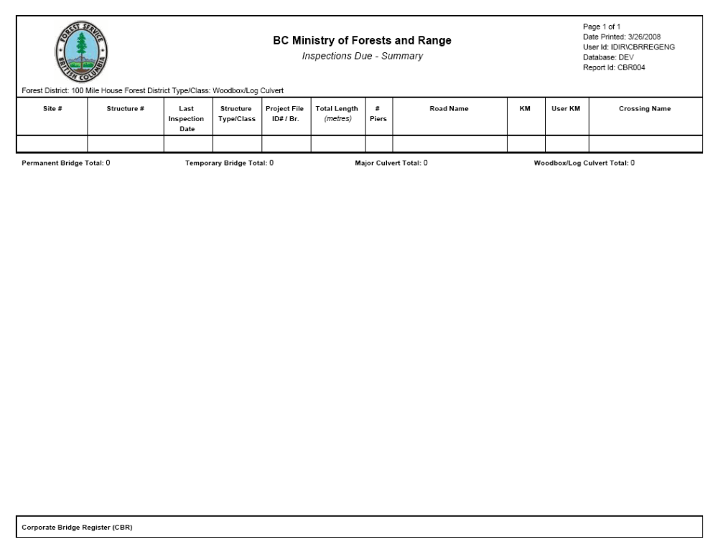
Object: | Page
Object: | Type: |  | Text
Object: | Description: |  | Displays the current page being displayed and the total number of pages in the report.
Object: | Data: |  | Output: The current page and the page count (Crystal Reports special fields).
Object: | Special Processing: |  | n/a
Object: | Date Printed
Object: | Type: |  | Text
Object: | Description: |  | Displays the date that the report was generated.
Object: | Data: |  | Output: The current date at the time of generation (Crystal Reports special field).
Object: | Special Processing: |  | n/a
Object: | User Id
Object: | Type: |  | Text
Object: | Description: |  | Displays the user who generated the report.
Object: | Data: |  | Output: The user id that requested the generation retrieved from WebADE and passed into the report.
Object: | Special Processing: |  | n/a
Object: | Database
Object: | Type: |  | Text
Object: | Description: |  | Displays the database environment that the report data was pulled from.
Object: | Data: |  | Output: The database used at the time of generation retrieved from WebADE and passed into the report.
Object: | Special Processing: |  | n/a
Object: | Report Id
Object: | Type: |  | Text
Object: | Description: |  | Displays a unique id for the report.
Object: | Data: |  | Output: Static report id specific to the report.
Object: | Special Processing: |  | n/a
Object: | Selected Criteria (located under the Forest Service Icon)
Object: | Type: |  | Text
Object: | Description: |  | Displays the criteria specified when generating the report.
Object: | Data: |  | Output: Criteria selected for generation of the report.
Object: | Special Processing: |  | n/a
Object: | Structure #
Object: | Type: |  | Text
Object: | Description: |  | Unique identifier assigned to each structure.
Object: | Data: |  | Output: Structure # for the record retrieved from CROSSING_STRUCTURE.CROSSING_STRUCTURE_ID.
Object: | Special Processing: |  | n/a
Object: | Site #
Object: | Type: |  | Text
Object: | Description: |  | Unique identifier for the physical site where a structure will be installed.
Object: | Data: |  | Output: Site # for the record retrieved from CROSSING_SITE.CROSSING_SITE_ID.
Object: | Special Processing: |  | n/a
Object: | Last Inspection Date
Object: | Type: |  | Text
Object: | Description: |  | The date of the last inspection for the structure that was ‘Accepted’.
Object: | Data: |  | Output: Last inspection date for the record is retrieved from STRUCTURE_INSPECTION.INSPECTION_DATE.
Object: | Special Processing: |  | n/a
Object: | Structure Type/Class
Object: | Type: |  | Text
Object: | Description: |  | Identifies the (major) structure type.
Object: | Data: |  | Output: A converted form of the value retrieved from CROSSING_STRUCTURE.STRUCTURE_TYPE_CLASS_CODE.
Object: | Special Processing: |  | Data retrieved is converted as follows:  PB B, TB T, CUL MC, WLC W
Object: | Project File ID# / Br.
Object: | Type: |  | Text
Object: | Description: |  | Project File ID# and Branch assigned to the particular site.
Object: | Data: |  | Output: Project Fie ID# for the record retrieved from CROSSING_SITE.FOREST_FILE_ID and Branch for the record retrieved from CROSSING_SITE.ROAD_SECTION_ID.
Object: | Special Processing: |  | n/a
Object: | Total Length
Object: | Type: |  | Text
Object: | Description: |  | For bridges: Length from one bridge end to the other end measured at bridge deck at center line.  For culverts: Length of a culvert along direction of the watercourse.
Object: | Data: |  | Output: Total length for bridge structures for the record retrieved from FOREST_SERVICE_BRIDGE.TOTAL_LENGTH. Total length for culvert structures for the record retrieved from FOREST_SERVICE_CULVERT.CULVERT_LENGTH.
Object: | Special Processing: |  | Different field is displayed depending on the structure type.
Object: | # Piers
Object: | Type: |  | Text
Object: | Description: |  | Identifies the number of piers associated with the structure.
Object: | Data: |  | Output: The number of associated records in the FOREST_SERVICE_BRIDGE_PIER table.
Object: | Special Processing: |  | n/a
Object: | Road Name
Object: | Type: | Text
Object: | Description: | Indicates the forest service road name for the associated site.
Object: | Data: | Output: Forest service road name for the record retrieved from ROAD_SECTION.ROAD_SECT_NAME.
Object: | Special Processing: | n/a
Object: | KM
Object: | Type: | Text
Object: | Description: | Distance in kilometres from the point of commencement to the road section or system.
Object: | Data: | Output: Kilometres for the record retrieved from CROSSING_SITE.POINT_OF_COMMENCEMENT_DISTANCE.
Object: | Special Processing: | n/a
Object: | User KM
Object: | Type: | Text
Object: | Description: | The posted distance (relative to a sign), may vary from the Point of Commencement Distance which should be the current measured distance from the start of the road.
Object: | Data: | Output: User kilometres for the record retrieved from CROSSING_SITE.USER_KM.
Object: | Special Processing: | n/a
Object: | Crossing Name
Object: | Type: | Text
Object: | Description: | Common name of crossing.
Object: | Data: | Output: Crossing name for the record retrieved from CROSSING_SITE.CROSSING_NAME.
Object: | Special Processing: | n/a
Object: | Permanent Bridge Total
Object: | Type: | Text
Object: | Description: | The number of permanent bridges in the report.
Object: | Data: | Output: A count of records where the CROSSING_STRUCTURE.STRUCTURE_TYPE_CLASS_CODE is PB.
Object: | Special Processing: | Only displayed once at the end of the report.
Object: | Temporary Bridge Total
Object: | Type: | Text
Object: | Description: | The number of temporary bridges in the report.
Object: | Data: | Output: A count of records where the CROSSING_STRUCTURE.STRUCTURE_TYPE_CLASS_CODE is TB.
Object: | Special Processing: | Only displayed once at the end of the report.
Object: | Major Culvert Total
Object: | Type: | Text
Object: | Description: | The number of major culverts in the report.
Object: | Data: | Output: A count of records where the CROSSING_STRUCTURE.STRUCTURE_TYPE_CLASS_CODE is CUL.
Object: | Special Processing: | Only displayed once at the end of the report.
Object: | Woodbox/Log Culvert Total
Object: | Type: | Text
Object: | Description: | The number of woodbox/log culverts in the report.
Object: | Data: | Output: A count of records where the CROSSING_STRUCTURE.STRUCTURE_TYPE_CLASS_CODE is WLC.
Object: | Special Processing: | Only displayed once at the end of the report.

Inspections Due – Detailed Report
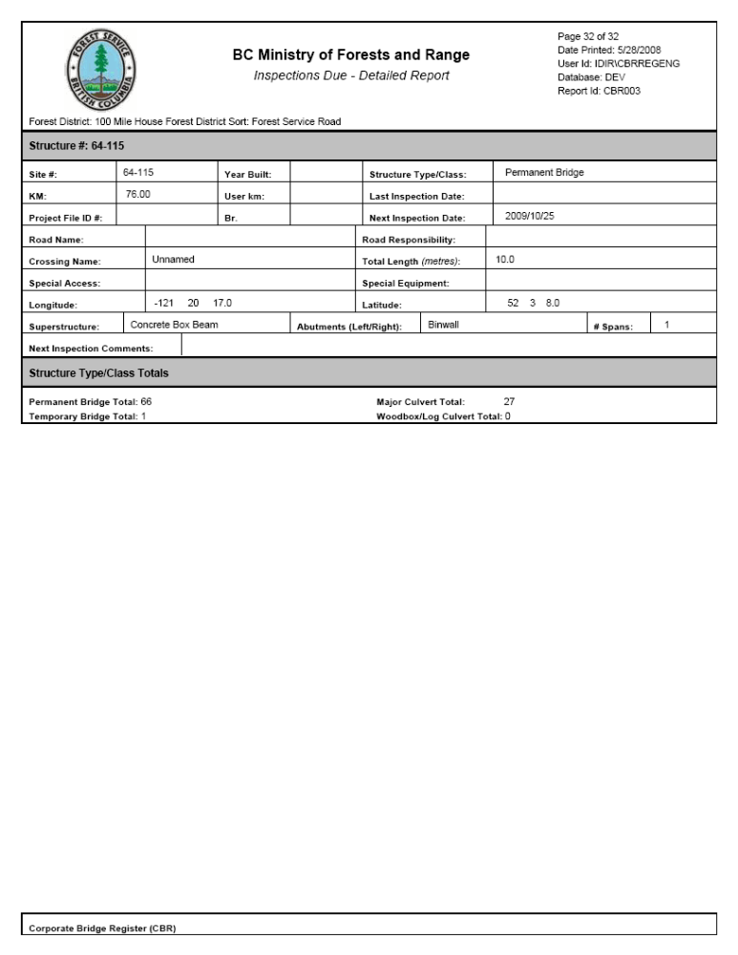
Object: | Page
Object: | Type: |  | Text
Object: | Description: |  | Displays the current page being displayed and the total number of pages in the report.
Object: | Data: |  | Output: The current page and the page count (Crystal Reports special fields).
Object: | Special Processing: |  | n/a
Object: | Date Printed
Object: | Type: |  | Text
Object: | Description: |  | Displays the date that the report was generated.
Object: | Data: |  | Output: The current date at the time of generation (Crystal Reports special field).
Object: | Special Processing: |  | n/a
Object: | User Id
Object: | Type: |  | Text
Object: | Description: |  | Displays the user who generated the report.
Object: | Data: |  | Output: The user id that requested the generation retrieved from WebADE and passed into the report.
Object: | Special Processing: |  | n/a
Object: | Database
Object: | Type: |  | Text
Object: | Description: |  | Displays the database environment that the report data was pulled from.
Object: | Data: |  | Output: The database used at the time of generation retrieved from WebADE and passed into the report.
Object: | Special Processing: |  | n/a
Object: | Report Id
Object: | Type: |  | Text
Object: | Description: |  | Displays a unique id for the report.
Object: | Data: |  | Output: Static report id specific to the report.
Object: | Special Processing: |  | n/a
Object: | Selected Criteria (located under the Forest Service Icon)
Object: | Type: |  | Text
Object: | Description: |  | Displays the criteria specified when generating the report.
Object: | Data: |  | Output: Criteria selected for generation of the report.
Object: | Special Processing: |  | n/a
Object: | Structure #
Object: | Type: |  | Text
Object: | Description: |  | Unique identifier assigned to each structure.
Object: | Data: |  | Output: Structure # for the record retrieved from CROSSING_STRUCTURE.CROSSING_STRUCTURE_ID.
Object: | Special Processing: |  | n/a
Object: | Site #
Object: | Type: |  | Text
Object: | Description: |  | Unique identifier for the physical site where a structure will be installed.
Object: | Data: |  | Output: Site # for the record retrieved from CROSSING_SITE.CROSSING_SITE_ID.
Object: | Special Processing: |  | n/a
Object: | Year Built
Object: | Type: |  | Text
Object: | Description: |  | The year that the construction of the structure was completed.
Object: | Data: |  | Output: Year built value for the record retrieved from CROSSING_STRUCTURE.YEAR_BUILT.
Object: | Special Processing: |  | n/a
Object: | Structure Type/Class
Object: | Type: |  | Text
Object: | Description: |  | Identifies the (major) structure type.
Object: | Data: |  | Output: The structure type/class value retrieved from CROSSING_STRUCTURE.STRUCTURE_TYPE_CLASS_CODE.
Object: | Special Processing: |  | n/a
Object: | KM
Object: | Type: | Text
Object: | Description: | Distance in kilometres from the point of commencement to the road section or system.
Object: | Data: | Output: Kilometres for the record retrieved from CROSSING_SITE.POINT_OF_COMMENCEMENT_DISTANCE.
Object: | Special Processing: | n/a
Object: | User km
Object: | Type: | Text
Object: | Description: | The posted distance (relative to a sign), may vary from the Point of Commencement Distance which should be the current measured distance from the start of the road.
Object: | Data: | Output: User kilometres for the record retrieved from CROSSING_SITE.USER_KM.
Object: | Special Processing: | n/a
Object: | Last Inspection Date
Object: | Type: |  | Text
Object: | Description: |  | The date of the last inspection for the structure that was ‘Accepted’.
Object: | Data: |  | Output: Last inspection date for the record is retrieved from STRUCTURE_INSPECTION.INSPECTION_DATE.
Object: | Special Processing: |  | n/a
Object: | Project File ID #
Object: | Type: | Text
Object: | Description: | Indicates the project file ID # for the associated site.
Object: | Data: | Output: Project File ID# for the record retrieved from CROSSING_SITE.FOREST_FILE_ID.
Object: | Special Processing: | n/a
Object: | Br.
Object: | Type: | Text
Object: | Description: | Indicates the Branch for the associated site.
Object: | Data: | Output: Branch for the record retrieved from CROSSING_SITE.ROAD_SECTION_ID.
Object: | Special Processing: | n/a
Object: | Next Inspection Date
Object: | Type: | Text
Object: | Description: | Projected date for the next planned inspection for the structure.
Object: | Data: | Output: Next planned inspection date for the record retrieved from CROSSING_STRUCTURE.NEXT_PLANNED_INSPECTION_DATE.
Object: | Special Processing: | n/a
Object: | Road Name
Object: | Type: | Text
Object: | Description: | Indicates the forest service road name for the associated site.
Object: | Data: | Output: Forest service road name for the record retrieved from ROAD_SECTION.ROAD_SECT_NAME.
Object: | Special Processing: | n/a
Object: | Road Responsibility
Object: | Type: | Text
Object: | Description: | Identifies who is responsible for the maintenance of the road.
Object: | Data: | Output: Road responsibility for the record retrieved from ROAD_SEGMENT.ROAD_RESPONSIBILITY_TYPE_CODE.
Object: | Special Processing: | n/a
Object: | Crossing Name
Object: | Type: | Text
Object: | Description: | Common name of crossing.
Object: | Data: | Output: Crossing name for the record retrieved from CROSSING_SITE.CROSSING_NAME.
Object: | Special Processing: | n/a
Object: | Total Length
Object: | Type: |  | Text
Object: | Description: |  | For bridges: Length from one bridge end to the other end measured at bridge deck at center line.  For culverts: Length of a culvert along direction of the watercourse.
Object: | Data: |  | Output: Total length for bridge structures for the record retrieved from FOREST_SERVICE_BRIDGE.TOTAL_LENGTH. Total length for culvert structures for the record retrieved from FOREST_SERVICE_CULVERT.CULVERT_LENGTH.
Object: | Special Processing: |  | Different field is displayed depending on the structure type.
Object: | Special Access
Object: | Type: |  | Text
Object: | Description: |  | Identifies special access requirements for accessing a site.
Object: | Data: |  | Output: Special access value for the record retrieved from CROSSING_SITE.SPECIAL_ACCESS_RQMT_CODE.
Object: | Special Processing: |  | n/a
Object: | Special Equipment
Object: | Type: |  | Text
Object: | Description: |  | Identifies special equipment required for accessing a site.
Object: | Data: |  | Output: Special equipment value for the record retrieved from CROSSING_SITE.SPECIAL_EQUIPMENT_RQMT_CODE.
Object: | Special Processing: |  | n/a
Object: | Longitude
Object: | Type: |  | Text
Object: | Description: |  | A global designation for the relative distance east or west from the Greenwich meridian.
Object: | Data: |  | Output: Longitude value for the record retrieved from CROSSING_SITE.LONGITUDE.
Object: | Special Processing: |  | Value retrieved from database is in decimal degrees so is converted to degrees, minutes, seconds for display.
Object: | Latitude
Object: | Type: |  | Text
Object: | Description: |  | A global designation for the relative distance north or south from the equator.
Object: | Data: |  | Output: Latitude value for the record retrieved from CROSSING_SITE.LATITUDE.
Object: | Special Processing: |  | Value retrieved from database is in decimal degrees so is converted to degrees, minutes, seconds for display.
Object: | Superstructure
Object: | Type: | Text
Object: | Description: | Identifies the type of the superstructure.
Object: | Data: | Output: Superstructure type value for the record retrieved from FOREST_SERVICE_BRIDGE.SUPERSTRUCTURE_TYPE_CODE.
Object: | Special Processing: | Field is only displayed for permanent and temporary bridge types.
Object: | Abutments (Left/Right)
Object: | Type: | Text
Object: | Description: | Identifies the type of the left and right abutment.
Object: | Data: | Output: Left abutment value for the record retrieved from FOREST_SERVICE_BRIDGE.LEFT_ABUTMENT_CODE. Right abutment value for the record retrieved from FOREST_SERVICE_BRIDGE.RIGHT_ABUTMENT_CODE.
Object: | Special Processing: | Field is only displayed for permanent and temporary bridge types.  If the left and right abutment are the same the type is only shown once otherwise the left and right type are displayed.
Object: | # Spans
Object: | Type: |  | Text
Object: | Description: |  | Identifies the number of spans for the structure.
Object: | Data: |  | Output: Number of spans value for the record retrieved from the record count in FOREST_SERVICE_BRIDGE_SPAN.
Object: | Special Processing: |  | Field is only displayed for permanent and temporary bridge types.
Object: | Next Inspection Comment
Object: | Type: |  | Text
Object: | Description: |  | Displays the comments associated with the next planned inspection date.
Object: | Data: |  | Output: Next planned inspection comments for the record retrieved from CROSSING_STRUCTURE.NEXT_PLANNED_INSPECTION_CMT.
Object: | Special Processing: |  | n/a
Object: | Permanent Bridge Total
Object: | Type: | Text
Object: | Description: | The number of permanent bridges in the report.
Object: | Data: | Output: A count of records where the CROSSING_STRUCTURE.STRUCTURE_TYPE_CLASS_CODE is PB.
Object: | Special Processing: | Only displayed once at the end of the report.
Object: | Temporary Bridge Total
Object: | Type: | Text
Object: | Description: | The number of temporary bridges in the report.
Object: | Data: | Output: A count of records where the CROSSING_STRUCTURE.STRUCTURE_TYPE_CLASS_CODE is TB.
Object: | Special Processing: | Only displayed once at the end of the report.
Object: | Major Culvert Total
Object: | Type: | Text
Object: | Description: | The number of major culverts in the report.
Object: | Data: | Output: A count of records where the CROSSING_STRUCTURE.STRUCTURE_TYPE_CLASS_CODE is CUL.
Object: | Special Processing: | Only displayed once at the end of the report.
Object: | Woodbox/Log Culvert Total
Object: | Type: | Text
Object: | Description: | The number of woodbox/log culverts in the report.
Object: | Data: | Output: A count of records where the CROSSING_STRUCTURE.STRUCTURE_TYPE_CLASS_CODE is WLC.
Object: | Special Processing: | Only displayed once at the end of the report.

Replacement Structures – Summary Report
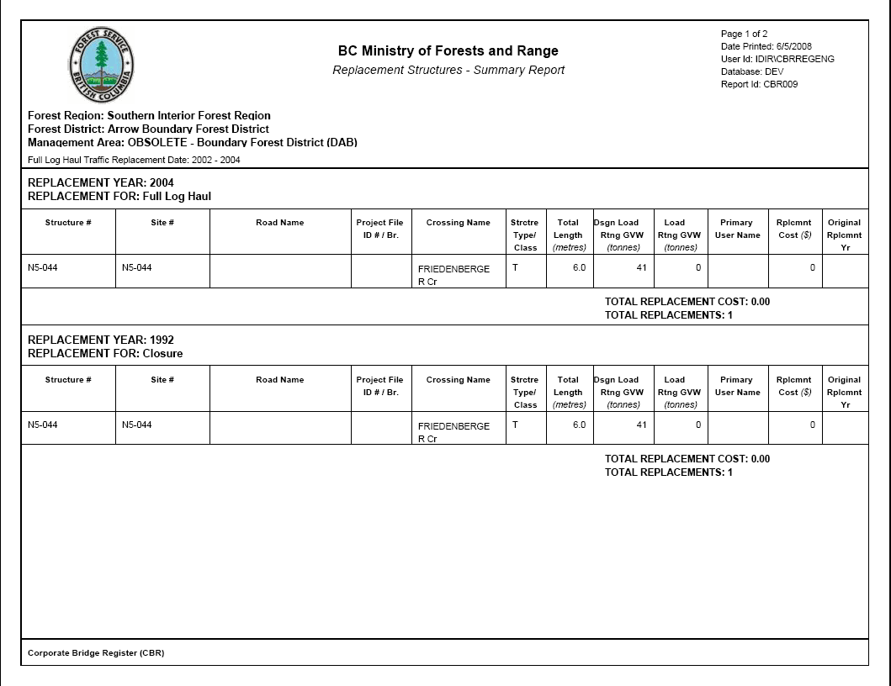

Object: | Page
Object: | Type: |  | Text
Object: | Description: |  | Displays the current page being displayed and the total number of pages in the report.
Object: | Data: |  | Output: The current page and the page count (Crystal Reports special fields).
Object: | Special Processing: |  | n/a
Object: | Date Printed
Object: | Type: |  | Text
Object: | Description: |  | Displays the date that the report was generated.
Object: | Data: |  | Output: The current date at the time of generation (Crystal Reports special field).
Object: | Special Processing: |  | n/a
Object: | User Id
Object: | Type: |  | Text
Object: | Description: |  | Displays the user who generated the report.
Object: | Data: |  | Output: The user id that requested the generation retrieved from WebADE and passed into the report.
Object: | Special Processing: |  | n/a
Object: | Database
Object: | Type: |  | Text
Object: | Description: |  | Displays the database environment that the report data was pulled from.
Object: | Data: |  | Output: The database used at the time of generation retrieved from WebADE and passed into the report.
Object: | Special Processing: |  | n/a
Object: | Report Id
Object: | Type: |  | Text
Object: | Description: |  | Displays a unique id for the report.
Object: | Data: |  | Output: Static report id specific to the report.
Object: | Special Processing: |  | n/a
Object: | Forest Region
Object: | Type: |  | Text
Object: | Description: |  | Displays the name of the Forest Region for the records on the page.
Object: | Data: |  | Output: The name of the Forest Region retrieved from ORG_UNIT.ORG_UNIT_NAME.
Object: | Special Processing: |  | n/a
Object: | Forest District
Object: | Type: |  | Text
Object: | Description: |  | Displays the name of the Forest District for the records on the page.
Object: | Data: |  | Output: The name of the Forest District retrieved from ORG_UNIT.ORG_UNIT_NAME.
Object: | Special Processing: |  | n/a
Object: | Management Area
Object: | Type: |  | Text
Object: | Description: |  | Displays the name of the Management Area for the records on the page.
Object: | Data: |  | Output: The name of the Management Area retrieved from ORG_UNIT.ORG_UNIT_NAME.
Object: | Special Processing: |  | n/a
Object: | Selected Criteria (located under the Forest Service Icon)
Object: | Type: |  | Text
Object: | Description: |  | Displays the criteria specified when generating the report.
Object: | Data: |  | Output: Criteria selected for generation of the report.
Object: | Special Processing: |  | Does not include Forest Region, Forest District or Management Area selections as they are displayed separately.
Object: | REPLACEMENT YEAR
Object: | Type: |  | Text
Object: | Description: |  | The replacement year for the group of structures beneath the heading.
Object: | Data: |  | Output: Replacement year for the record retrieved from CROSSING_STRUCTURE.ESTIMATED_CLOSURE_DATE, CROSSING_STRUCTURE.LIGHT_VEHICLE_TRFFC_RPLCMNT_DT or CROSSING_STRUCTURE.FULL_LOG_HAUL_TRFFC_RPLCMNT_DT (field displayed depends on the replacement type).
Object: | Special Processing: |  | Year displayed is based on the replacement type (closure, full log, light vehicle).
Object: | REPLACEMENT FOR
Object: | Type: |  | Text
Object: | Description: |  | The description of what the replacement year is for.
Object: | Data: |  | Output: The type of replacement (Closure, Full Log Haul or Light Vehicle).
Object: | Special Processing: |  | n/a
Object: | Structure #
Object: | Type: |  | Text
Object: | Description: |  | Unique identifier assigned to each structure.
Object: | Data: |  | Output: Structure # for the record retrieved from CROSSING_STRUCTURE.CROSSING_STRUCTURE_ID.
Object: | Special Processing: |  | n/a
Object: | Site #
Object: | Type: |  | Text
Object: | Description: |  | Unique identifier for the physical site where a structure will be installed.
Object: | Data: |  | Output: Site # for the record retrieved from CROSSING_SITE.CROSSING_SITE_ID.
Object: | Special Processing: |  | n/a
Object: | Road Name
Object: | Type: | Text
Object: | Description: | Indicates the forest service road name for the associated site.
Object: | Data: | Output: Forest service road name for the record retrieved from ROAD_SECTION.ROAD_SECT_NAME.
Object: | Special Processing: | n/a
Object: | Project File ID #
Object: | Type: | Text
Object: | Description: | Indicates the project file ID # for the associated site.
Object: | Data: | Output: Project File ID# for the record retrieved from CROSSING_SITE.FOREST_FILE_ID.
Object: | Special Processing: | n/a
Object: | Br.
Object: | Type: | Text
Object: | Description: | Indicates the Branch for the associated site.
Object: | Data: | Output: Branch for the record retrieved from CROSSING_SITE.ROAD_SECTION_ID.
Object: | Special Processing: | n/a
Object: | Crossing Name
Object: | Type: | Text
Object: | Description: | Common name of crossing.
Object: | Data: | Output: Crossing name for the record retrieved from CROSSING_SITE.CROSSING_NAME.
Object: | Special Processing: | n/a
Object: | Strctre Type/Class
Object: | Type: |  | Text
Object: | Description: |  | Identifies the (major) structure type.
Object: | Data: |  | Output: The structure type/class value retrieved from CROSSING_STRUCTURE.STRUCTURE_TYPE_CLASS_CODE.
Object: | Special Processing: |  | n/a
Object: | Total Length
Object: | Type: |  | Text
Object: | Description: |  | For bridges: Length from one bridge end to the other end measured at bridge deck at center line.  For culverts: Length of a culvert along direction of the watercourse.
Object: | Data: |  | Output: Total length for bridge structures for the record retrieved from FOREST_SERVICE_BRIDGE.TOTAL_LENGTH. Total length for culvert structures for the record retrieved from FOREST_SERVICE_CULVERT.CULVERT_LENGTH.
Object: | Special Processing: |  | Different field is displayed depending on the structure type.
Object: | Dsgn Load Trng GVW
Object: | Type: |  | Text
Object: | Description: |  | The design load rating for the given structure.
Object: | Data: |  | Output: Design load rating for the structure retrieved from CROSSING_STRUCTURE.DESIGN_LOAD_RATING.
Object: | Special Processing: |  | n/a
Object: | Load Rtng GVW
Object: | Type: | Text
Object: | Description: | The current load rating for the given structure.
Object: | Data: | Output: The current load rating for the structure retrieved from CROSSING_STRUCTURE.LOAD_RATING.
Object: | Special Processing: | n/a
Object: | Primary User Name
Object: | Type: | Text
Object: | Description: | The name of the primary user associated with the structure.
Object: | Data: | Output: The name of the primary user associated with the structure retrieved from FOREST_CLIENT.CLIENT_NAME (based on the relationship in CROSSING_STRUCTURE).
Object: | Special Processing: | n/a
Object: | Rplcmnt Cost
Object: | Type: | Text
Object: | Description: | The estimated cost to replace the structure.
Object: | Data: | Output: The estimated replacement cost retrieved from CROSSING_STRUCTURE.ESTIMATED_REPLACEMENT_COST.
Object: | Special Processing: | n/a
Object: | Original Rplcmnt Yr
Object: | Type: | Text
Object: | Description: | The year the structure was originally replaced.
Object: | Data: | Output: The original replacement year retrieved from CROSSING_STRUCTURE.ORIGINAL_REPLACEMENT_DATE.
Object: | Special Processing: | n/a
Object: | TOTAL REPLACEMENT COST
Object: | Type: | Text
Object: | Description: | The total replacement cost for the given replacement/type grouping.
Object: | Data: | Output: A sum of the replacement cost for the records displayed under the associated year/type heading.
Object: | Special Processing: | n/a
Object: | TOTAL REPLACEMENTS
Object: | Type: | Text
Object: | Description: | The total number of replacements for the given replacement year/type grouping.
Object: | Data: | Output: The count of records displayed under the associated year/type heading.
Object: | Special Processing: | n/a

Sign-Off
Following sign-off of this document, changes must be approved through a change request.
Accepted by | Signature | Date
- Mark Ismay  - Senior Development Analyst  - Ministry of Forests and Range | - ________________________________________ | - _______________
- Glen Moore  - Senior Structures and Roads Engineer  - Ministry of Forests and Range | - ________________________________________ | - _______________

Document Revisions
REVISIONS | DATE | AUTHOR | SECTIONS MODIFIED
- 1.0 | - April 2, 2009 | - Salus Systems Ltd. | - Moved contents out of original Design Specifications into Report Design Specifications document due to size (document was becoming hard to review).  - Made modifications to Section 2 for release 1.3 enhancements.

